- What variables are represented in the graph? Also tell the relationship between the variables.
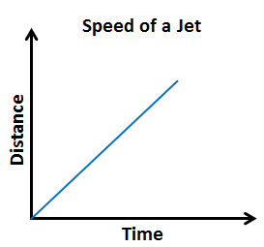
- Write the table representing the graph shown below.
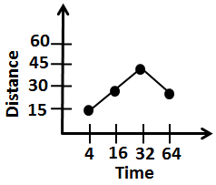

- Sketch a graph representing the situation given below.
Harry’s time in office starting from morning till the evening.

- Distance from a city decreasing with time is an example of:

  - Linearly increasing relation
  - Linearly decreasing relation
  - Constant relation
  - None of these
- For the diagram given below, find the relationship between the number of shapes and the perimeter of the figure they form. Then represent this relationship using words and an
equation.
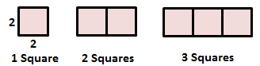
- For the diagram given below, find the relationship between the number of shapes and the perimeter of the figure they form. Then represent this relationship using a table.
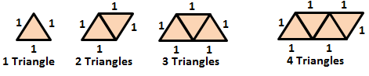

x | 1 | 3 | 5 | 7 | 9
y | 3 | 5 | 7 | 9 | 11
- For the table given below, determine whether the relationship is a function. If yes, then represent the relation using words and ordered pairs.

- The perimeter of a square having side equal to 4 is:
  - 8
  - 12
  - 4
  - 16

x | y
0 | 1
1 | 2
2 | 5
3 | 10
- Graph the function represented by the data in the table. Tell whether the function is linear or non-linear.

Graph:

- The set of ordered pairs represents a function. Write a rule representing the function.
(-1,1), (0,2), (1,3), (2,10), (3,29)
Rule:
- The set of ordered pairs represents a function. Write a rule representing the function.
(0,-1), (1,0), (2, 1), (3,2), (4,3)
Rule:
- A function whose graph is not a straight line is a:
  - Quadratic function
  - Linear function
  - Nonlinear function
  - None of these
- Make a table of values of the function given. Then graph the function rule using the table of values.
$y= \frac{x}{3}$

Graph:
- Make a table of values of the function given. Then graph the function rule using the table of values.
$y=\left|x-2\right|+1$

Graph:

- Graph the function rule. Also tell whether the function is continuous or discrete.
The cost d in dollars, of the number n of tickets bought for a baseball game is related as $d=10n$.
- Which one of this is a type of function graphs?
  - Atomic function graph
  - Linear function graph
  - Nonlinear function graph
  - Both b and c

- Write a function rule representing the verbal statement given below.
5 times $w$ increased by 4 is 2 times $u$.
- Write a function rule representing the situation given below.
The cost $c$ of the membership of a club is 30$ for sign up and 15$ per week $w$ to be a member.
- A taxi cab charges 3$ for the first mile and 1.5$ for each additional mile. Write a rule for describing the total rate $r$ as a function of miles $m$. What is the taxi rate for 16 miles?
- The word ‘ratio’ in a mathematical verbal statement suggests that the mathematical operation to be used is:

  - Addition
  - Multiplication
  - Division
  - Subtraction

- A mathematical verbal statement is a translation into words, of an equation (or an expression) containing:
  - Numbers
  - Variables
  - Operations
  - All of these
- Identify the domain and range of the relation given below. Use a mapping diagram to determine whether the relation is a function or not.
R = {(5,2.2),(3,2.6),(1,2.6),(0,2.5)}
- Use the vertical line test to determine whether the relation is a function.
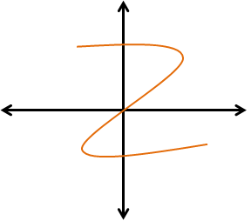

- Find the range of the function given its domain.
$f\left(x\right)=x^{2}-5$ ; {-2,1,0,2}
Range:
- If a vertical line passes through more than 1 point on the graph at one time, then the graph is a:

  - Function
  - Relation
  - Not a Function
  - None of these
- Find the range of the function given its domain.
$f\left(x\right)=x^{3}+12$ ; {-3,-1,1,2}
Range:
- Describe the pattern in the sequence given below. Also find the next three terms in the sequence.
1, 3, 9, 27, 54, …
- Tell whether the sequence in given below is arithmetic or not. If it is, identify the common difference.
4, 7, 10, 13, 16, …

- Find the n^{th} term in the arithmetic sequence given.
5th term in $\frac{1}{4}$, $\frac{1}{2}$,$\frac{3}{4}$, …
- The sequence 0, $\frac{1}{3}$, $\frac{2}{3}$, 1, … is a/an:

  - Geometric sequence
  - Arithmetic sequence
  - Harmonic sequence
  - None of these
ANSWERS
- What variables are represented in the graph? Also tell the relationship between the variables.
Distance and Time, Distance increases with the increase in time.
Time | Distance
4 | 15
16 | 30
32 | 45
64 | 30
- Write the table representing the graph shown below.

- Sketch a graph representing the situation given below.
Harry’s time in office starting from morning till the evening.
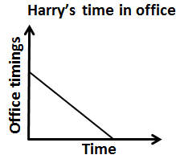
- Distance from a city decreasing with time is an example of:

  - Linearly increasing relation
  - Linearly decreasing relation
  - Constant relation
  - None of these
- For the diagram given below, find the relationship between the number of shapes and the perimeter of the figure they form. Then represent this relationship using words and an
equation.
Using words: The perimeter is 4 more than 4 times the number of squares.
Using Equation: $P=4n+4$ ; P = Perimeter, $n$ = number of squares
- For the diagram given below, find the relationship between the number of shapes and the perimeter of the figure they form. Then represent this relationship using a table.
Using table:
Number of Triangles | 1 | 2 | 3 | 4
Perimeter | 3 | 4 | 5 | 6

x | 1 | 3 | 5 | 7 | 9
y | 3 | 5 | 7 | 9 | 11
- For the table given below, determine whether the relationship is a function. If yes, then represent the relation using words and ordered pairs.

Yes, it is a function.
Using words: y is 2 more than x
Using ordered pairs: (1,3), (3,5), (5,7), (7,9), (9,11)

- The perimeter of a square having side equal to 4 is:
  - 8
  - 12
  - 4
  - 16

x | y
0 | 1
1 | 2
2 | 5
3 | 10
- Graph the function represented by the data in the table. Tell whether the function is linear or non-linear.

Graph:
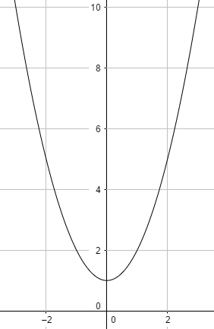
- The set of ordered pairs represents a function. Write a rule representing the function.
(-1,1), (0,2), (1,3), (2,10), (3,29)
Rule: $y= x^{3}+2$
- The set of ordered pairs represents a function. Write a rule representing the function.
(0,-1), (1,0), (2, 1), (3,2), (4,3)
Rule: $y= x-1$
- A function whose graph is not a straight line is a:
  - Quadratic function
  - Linear function
  - Nonlinear function
  - None of these
x | y
$-$6 | $-$2
$-$3 | $-$1
3 | 1
6 | 2
- Make a table of values of the function given. Then graph the function rule using the table of values.
$y= \frac{x}{3}$

Graph:
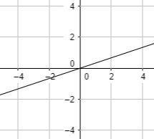
x | y
0 | 3
1 | 2
2 | 1
3 | 2
4 | 3
- Make a table of values of the function given. Then graph the function rule using the table of values.
$y=\left|x-2\right|+1$

Graph:
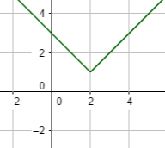

- Graph the function rule. Also tell whether the function is continuous or discrete.
The cost d in dollars, of the number n of tickets bought for a baseball game is related as $d=10n$.
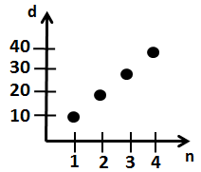
The function is discrete since the graph is discrete.
- Which one of this is a type of function graphs?
  - Atomic function graph
  - Linear function graph
  - Nonlinear function graph
  - Both b and c

- Write a function rule representing the verbal statement given below.
5 times $w$ increased by 4 is 2 times $u$.
____$2u=5w+4$____
- Write a function rule representing the situation given below.
The cost $c$ of the membership of a club is 30$ for sign up and 15$ per week $w$ to be a member.
____$c=30+15w$____
- A taxi cab charges 3$ for the first mile and 1.5$ for each additional mile. Write a rule for describing the total rate $r$ as a function of miles $m$. What is the taxi rate for 16 miles?
Rule: ___$r=3+1.5(m-1)$___
when $m=16$,
$r=3+1.5(16-1)$
$r=3+22.5=25.5\$$
- The word ‘ratio’ in a mathematical verbal statement suggests that the mathematical operation to be used is:

  - Addition
  - Multiplication
  - Division
  - Subtraction

- A mathematical verbal statement is a translation into words, of an equation (or an expression) containing:
  - Numbers
  - Variables
  - Operations
  - All of these
- Identify the domain and range of the relation given below. Use a mapping diagram to determine whether the relation is a function or not.
R = {(5,2.2),(3,2.6),(1,2.6),(0,2.5)}
Domain: {0,1,3,5}
Range: {2.2,2.5,2.6}
Mapping diagram:
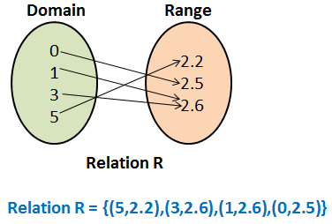
It is a function
- Use the vertical line test to determine whether the relation is a function.
It is not a function since some vertical lines pass through more than 1 point on the function.

- Find the range of the function given its domain.
$f\left(x\right)=x^{2}-5$ ; {-2,1,0,2}
Range: {-1,-4,-5,-1}
- If a vertical line passes through more than 1 point on the graph at one time, then the graph is a:

  - Function
  - Relation
  - Not a Function
  - None of these
- Find the range of the function given its domain.
$f\left(x\right)=x^{3}+12$ ; {-3,-1,1,2}
Range: {-15,11,13,20}
- Describe the pattern in the sequence given below. Also find the next three terms in the sequence.
1, 3, 9, 27, 54, …
Pattern: Each term is 3 times the previous one.
Next three terms: 54 $×$ 3 = 162
15 $×$ 2 = 486
17 $×$ 2 = 1458
- Tell whether the sequence in given below is arithmetic or not. If it is, identify the common difference.
4, 7, 10, 13, 16, …
Common difference: 7 – 4 = 3 = 10 - 7
Since the common difference is same, it is an arithmetic sequence.

- Find the n^{th} term in the arithmetic sequence given.
5th term in $\frac{1}{4}$, $\frac{1}{2}$,$\frac{3}{4}$, …
Common difference: $\frac{1}{2}$ - $\frac{1}{4}$ = $\frac{1}{4}$ = $\frac{3}{4}$ – $\frac{1}{2}$
$a_{n}=a_{1}+\left(n-1\right).d$
$a_{5}=\frac{1}{4}+\left(5-1\right).\frac{1}{4}$
$a_{5}=\frac{1}{4}+1=\frac{5}{4}$
- The sequence 0, $\frac{1}{3}$, $\frac{2}{3}$, 1, … is a/an:

  - Geometric sequence
  - Arithmetic sequence
  - Harmonic sequence
  - None of these

