- What variables are represented in the graph? Also tell the relationship between the variables.
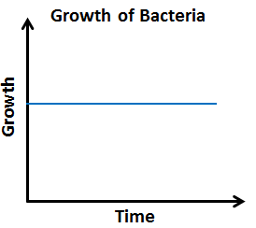
- Write the table representing the graph shown below.
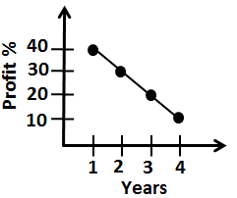

- Sketch a graph representing the situation given below.
Alan’s distance from home as he leaves from his home to his office.

- For the diagram given below, find the relationship between the number of shapes and the perimeter of the figure they form. Then represent this relationship using words and an
equation.
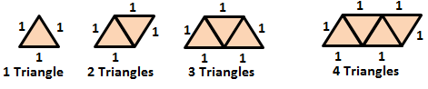

y | 0 | 1 | 2 | 3 | 4
z | 6 | 7 | 8 | 9 | 10
- For the table given below, determine whether the relationship is a function. If yes, then represent the relation using words and ordered pairs.

- A function whose graph is a straight line is a:

  - Quadratic function
  - Linear function
  - Cubic function
  - None of these
x | y
-2 | 0
-1 | 1
0 | 2
1 | 3
- Graph the function represented by the data in the table. Tell whether the function is linear or non-linear.

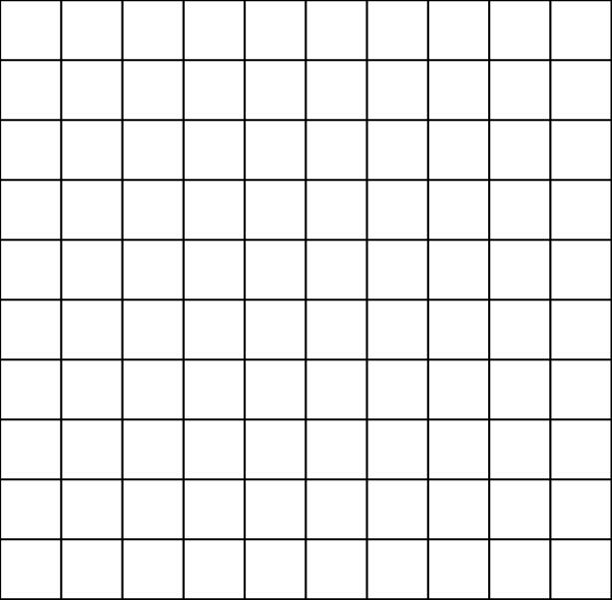
Graph:

- The set of ordered pairs represents a function. Write a rule representing the function.
(-1,2), (0,1), (1,2), (2,5), (3,10)
Rule:
- Which one of these is used for representing the relationship in a pattern?

  - Table
  - Ordered pairs
  - Equation
  - All of these
- The graph of a quadratic function $y= x^{2}$ is a:

  - Continuous graph
  - Discrete graph
  - Both a and b
  - None of these
- Make a table of values of the function given. Then graph the function rule using the table of values.
$y= x^{3}+1$

Graph:
- The amount of water w in a swimming pool, in liters, depends on the amount of time t the swimming pool is filled with water and is related by the function rule $w=1.5t$. Graph the function and tell whether the function is continuous or discrete.
- Write a function rule representing the verbal statement given below.
2.5 more than quotient of $a$ and 4 is $b$.
- Write a function rule representing the situation given below.
The price $p$ of a pizza is 4.95$ plus 0.5$ for each topping $t$ on the pizza.
- The function rule representing the verbal statement ‘Twice a number $x$ increased by 3 equals $y$’ is:

  - $2x-3=y$
  - $2x+3=y$
  - $3x+2=y$
  - $2y-3=x$
- Alan is 3 years younger than 2 times his brother age. Write a rule that represents Alan’s age $a$ as a function of his brother’s age $b$. How old is Alan if his brother is 11?

- Identify the domain and range of the relation given below. Use a mapping diagram to determine whether the relation is a function or not.
R = {(-4,-1),(1,-2),(-4,3),(-1,-6)}
- Use the vertical line test to determine whether the relation is a function.
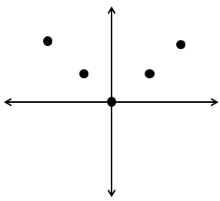

- Tell whether the sequence in given below is arithmetic or not. If it is, identify the common difference.
-11, 5, 0, 7, …
- Find the n^{th} term in the arithmetic sequence given.
9th term in -11, -1, 9, 19, …

- What variables are represented in the graph? Also tell the relationship between the variables.
Growth and Time, Growth of bacteria remains constant with the increase in time.
Years | Profit %
1 | 40
2 | 30
3 | 20
4 | 40
- Write the table representing the graph shown below.

- Sketch a graph representing the situation given below.
Alan’s distance from home as he leaves from his home to his office.
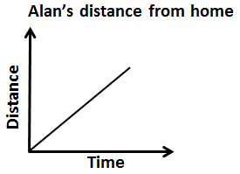
- For the diagram given below, find the relationship between the number of shapes and the perimeter of the figure they form. Then represent this relationship using words and an
equation.
Using words: The perimeter is 2 more than the number of triangles
Using Equation: $P=n+2$ ; P = Perimeter, $n$ = number of triangles
y | 0 | 1 | 2 | 3 | 4
z | 6 | 7 | 8 | 9 | 10
- For the table given below, determine whether the relationship is a function. If yes, then represent the relation using words and ordered pairs.

Yes, it is a function.
Using words: z is 6 more than y
Using ordered pairs: (0,6), (1,7), (2,8), (3,9), (4,10)

- A function whose graph is a straight line is a:

  - Quadratic function
  - Linear function
  - Cubic function
  - None of these
x | y
-2 | 0
-1 | 1
0 | 2
1 | 3
- Graph the function represented by the data in the table. Tell whether the function is linear or non-linear.

Graph:
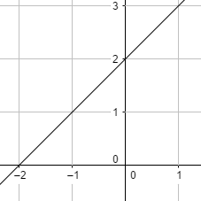

- The set of ordered pairs represents a function. Write a rule representing the function.
(-1,2), (0,1), (1,2), (2,5), (3,10)
Rule: $y= x^{2}+1$
- Which one of these is used for representing the relationship in a pattern?

  - Table
  - Ordered pairs
  - Equation
  - All of these
- The graph of a quadratic function $y= x^{2}$ is a:

  - Continuous graph
  - Discrete graph
  - Both a and b
  - None of these
x | y
$-$2 | $-$7
$-$1 | 0
0 | 1
1 | 2
2 | $9$
- Make a table of values of the function given. Then graph the function rule using the table of values.
$y= x^{3}+1$

Graph:
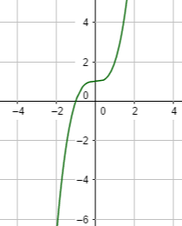
- The amount of water w in a swimming pool, in liters, depends on the amount of time t the swimming pool is filled with water and is related by the function rule $w=1.5t$
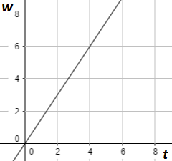
The function is continuous since the graph is continuous.
- Write a function rule representing the verbal statement given below.
2.5 more than quotient of $a$ and 4 is $b$.
____$b=2.5+\frac{a}{4}$____
- Write a function rule representing the situation given below.
The price $p$ of a pizza is 4.95$ plus 0.5$ for each topping $t$ on the pizza.
____$p=4.95+0.5t$____
- The function rule representing the verbal statement ‘Twice a number $x$ increased by 3 equals $y$’ is:

  - $2x-3=y$
  - $2x+3=y$
  - $3x+2=y$
  - $2y-3=x$
- Alan is 3 years younger than 2 times his brother age. Write a rule that represents Alan’s age $a$ as a function of his brother’s age $b$. How old is Alan if his brother is 11?
Rule: ___$a=2b-3$___
when $b=11$,
$a=2\left(11\right)-3$
$a=22-3=19 years$
- Identify the domain and range of the relation given below. Use a mapping diagram to determine whether the relation is a function or not.
R = {(-4,-1),(1,-2),(-4,3),(-1,-6)}
Domain: {-4,-1,1}
Range: {-6,-2,-1,3}
Mapping diagram:
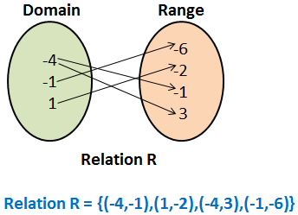
It is not a function
- Use the vertical line test to determine whether the relation is a function.
It is a function since any vertical line passes through only 1 point on the function.
- Tell whether the sequence in given below is arithmetic or not. If it is, identify the common difference.
-11, 5, 0, 7, …
Common difference: 5 – (-11) = 17 $≠$ 0 - 5
Since the common difference is not the same, it is not an arithmetic sequence.
- Find the n^{th} term in the arithmetic sequence given.
9th term in -11, -1, 9, 19, …
Common difference: -1 – (-11) = 10 = 9 – (-1)
$a_{n}=a_{1}+\left(n-1\right).d$
$a_{9}=-11+\left(9-1\right).10$
$a_{6}=-11+80=69$

