Game | Goals
1 | 3
2 | 6
3 | 9
- Determine whether the rate of change is constant for the data set. If yes, identify the rate of change both numerically and in words.
Football Game’s Stats

- Find the slope of the line given below.
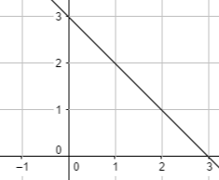

- Find the slope of the line passing through the points (1,0) and (-4,2).

- The slope of a vertical line is:

  - zero
  - undefined
  - 1
  - None of these
$$x$$ | $$y$$
6 | -6.9
-10 | -11.5
7 | -8.05
- For the data in the table, tell whether $y$ varies directly with $x$. If it does, write an equation for the direction equation.

- Which of the following equations represent a direct variation?
  - $y=2x+1$
  - $3x-2y=0$
  - $9y-9=9x$
  - Both b and c

- Determine whether the given below equation represents a direct variation or not. If it does, find the constant of variation.
$3y-7=2x-7$

- Assume that $y$ varies directly with $x$. Write an equation relating $x$ and $y$. Also find the value of $y$ when is 6.
$y=-\frac{4}{5}$ when $x=-4$

- Find the slope and $y$-intercept of the linear equation $y=-2.5x-3.01$.

- Write an equation of a line with the given slope $m$ and y-intercept $b$.
$m= 0.4, b=1$

- Write an equation in slope-intercept form of the line that passes through the points $\left(12,10\right)and \left(16,8\right)$.

- The slope formula is given as:

  - $Slope m=\frac{y_{2}-y_{1}}{x_{2}-x_{1}}$
  - $Slope m=\frac{x_{2}-x_{1}}{y_{2}-y_{1}}$
  - $Slope m=x_{2}-x_{1}$
  - $Slope m=y_{2}-y_{1}$

- Write an equation in point-slope form of the line passing through the point given below and having slope $m$.
$(-3,-5)$ ; $m=-2$

- The point-slope form of a linear equation is:

  - $y-x_{1}=m(x-y_{1})$
  - $y-y_{1}=m(x-x_{1})$
  - $y=mx+b$
  - None of these

- Write an equation in slope-intercept form of the line passing through $\left(3,1\right) and (4,3)$.


- Graph the equation $y+3=2(x+1)$.
- Find the $x$- and $y$- intercepts of the graph of the equation given below.
$x-2y=6$

- For the equation $y=0$, tell whether its graph is a horizontal or vertical line. Give reason for your answer.
- Graph the equation $4x-8y=12$ using $x$- and $y$-intercepts.
- The point $(0,-2)$ represents a/an:

  - x-intercept
  - y-intercept
  - z-intercept
  - None of these
- Write an equation in slope-intercept form of the line that passes through the given point and is parallel to the graph of the given equation.
$\left(-1,6\right) ; y=9x-5$

- Write an equation in slope-intercept form of the line that passes through the given point and is perpendicular to the graph of the given equation.
$\left(2,1\right) ; y=2x+1$
- Determine whether the graphs of the given equations are parallel or perpendicular or neither. Give reason for your answer.
$y-x=10$
$y=-x-4$
- The slope of the line perpendicular to the line $y=3x+6$ is:

  - $-3$
  - $\frac{1}{3}$
  - $-\frac{1}{3}$
  - 3

- The correlation between two data sets can be:
  - Positive
  - Negative
  - Both a and b
  - None of these

- For each table, make the scatter plot of the data. Describe the type of correlation the scatter plot shows.
Number of Questions | 2 | 4 | 6 | 8 | 10
Time taken to Solve (in min.) | 10 | 20 | 30 | 40 | 50

Graph:

- Describe how the slope of a line relates to a trend line. What does the y-intercept represent?

- Graph the equation $y=\left|x\right|-1$ by translating the function $y=|x|$.

- Write the equation represented by the graph shown below.
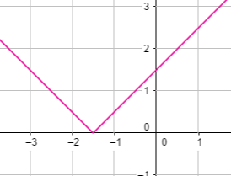

- Graph the equation $y=-|x-2|$ by reflecting and translating the function $y=|x|$.

Game | Goals
1 | 3
2 | 6
3 | 9
- Determine whether the rate of change is constant for the data set. If yes, identify the rate of change both numerically and in words.
Football Game’s Stats

Rate of change is constant.
Numerically: $\frac{6-3}{2-1}=3$
In Words: 3 goals per games played.

- Find the slope of the line given below.
$Slope= \frac{rise}{run}$
$rise=-1$ , $run=1$
$Slope= \frac{-1}{1}=-1$

- Find the slope of the line passing through the points (1,0) and (-4,2).
$Slope m=\frac{y_{2}-y_{1}}{x_{2}-x_{1}}$
$Slope m=\frac{2-0}{-4-1}$
$Slope m=-\frac{2}{5}$
- The slope of a vertical line is:

  - zero
  - undefined
  - 1
  - None of these
$$x$$ | $$y$$
6 | -6.9
-10 | -11.5
7 | -8.05
- For the data in the table, tell whether $y$ varies directly with $x$. If it does, write an equation for the direction equation.
The ratio $\frac{y}{x}= \frac{-6.9}{6}=-1.15≠ \frac{-11.5}{-10}$
The ratio is not constant, so it is not a direct variation.

- Which of the following equations represent a direct variation?
  - $y=2x+1$
  - $3x-2y=0$
  - $9y-9=9x$
  - Both b and c
- Determine whether the given below equation represents a direct variation or not. If it does, find the constant of variation.
$3y-7=2x-7$

$3y=2x-7+7$
$y=\frac{2}{3}x$
Yes it represents a direct variation.
$k= \frac{2}{3}$
- Assume that $y$ varies directly with $x$. Write an equation relating $x$ and $y$. Also find the value of $y$ when is 6.
$y=-\frac{4}{5}$ when $x=-4$
$k= \frac{-4/5}{-4}=\frac{1}{5}$
$y=\frac{1}{5}x$
When $x=6$
$y=\frac{1}{5}\left(6\right)=\frac{6}{5}$
- Find the slope and $y$-intercept of the linear equation $y=-2.5x-3.01$.
$Slope m=-2.5$
$y-intercept=-3.01$
- Write an equation of a line with the given slope $m$ and y-intercept $b$.
$m= 0.4, b=1$
$y=mx+b$
$y=0.4x+1$

- Write an equation in slope-intercept form of the line that passes through the points $\left(12,10\right)and \left(16,8\right)$.
$Slope m=\frac{8-10}{16-12}=-\frac{1}{2}$
$y=mx+b$ $→$ $10=-\frac{1}{2}\left(12\right)+b$
$b=16$
$y=-\frac{1}{2}x+16$

- The slope formula is given as:

  - $Slope m=\frac{y_{2}-y_{1}}{x_{2}-x_{1}}$
  - $Slope m=\frac{x_{2}-x_{1}}{y_{2}-y_{1}}$
  - $Slope m=x_{2}-x_{1}$
  - $Slope m=y_{2}-y_{1}$

- Write an equation in point-slope form of the line passing through the point given below and having slope $m$.
$(-3,-5)$ ; $m=-2$
$y-y_{1}=m(x-x_{1})$
$y-\left(-5\right)=-2\left(x-\left(-3\right)\right)$
$y+5=-2(x+3)$
- The point-slope form of a linear equation is:

  - $y-x_{1}=m(x-y_{1})$
  - $y-y_{1}=m(x-x_{1})$
  - $y=mx+b$
  - None of these

- Write an equation in slope-intercept form of the line passing through $\left(3,1\right) and (4,3)$.
$Slope m=\frac{3-1}{4-3}=2$
Put $(3,1)$ in $y-y_{1}=m\left(x-x_{1}\right)$:
$y-1=2(x-3)$
$y=2x-5$
- Graph the equation $y+3=2(x+1)$.
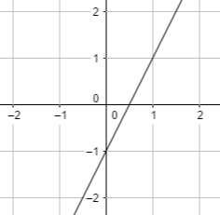
- Find the $x$- and $y$- intercepts of the graph of the equation given below.
$x-2y=6$
For $x$-intercept, put $y=0$
$x-2(0)=6$ $→$ $x= 6$
For $y$-intercept, put $x=0$
$x-2y=6$ $→$ $y=-3$
- For the equation $y=0$, tell whether its graph is a horizontal or vertical line. Give reason for your answer.
The equation has no $y$-intercept. So, the equation represents a horizontal line.
- Graph the equation $4x-8y=12$ using $x$- and $y$-intercepts.
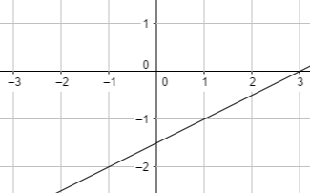
- The point $(0,-2)$ represents a/an:

  - x-intercept
  - y-intercept
  - z-intercept
  - None of these
- Write an equation in slope-intercept form of the line that passes through the given point and is parallel to the graph of the given equation.
$\left(-1,6\right) ; y=9x-5$
Slope of the parallel line $m=9$
$y-y_{1}=m(x-x_{1})$
$y-6=9\left(x-\left(-1\right)\right)$
$y=9x+15$
- Write an equation in slope-intercept form of the line that passes through the given point and is perpendicular to the graph of the given equation.
$\left(2,1\right) ; y=2x+1$
Slope of the perpendicular line $m=-\frac{1}{2}$
$y-y_{1}=m(x-x_{1})$
$y-1=-\frac{1}{2}(x-2)$
$y=-\frac{1}{2}x+2$
- Determine whether the graphs of the given equations are parallel or perpendicular or neither. Give reason for your answer.
$y-x=10$
$y=-x-4$
The graphs of the two lines are perpendicular since the slope of both lines are reciprocal of each other and their product is $–1$.
- The slope of the line perpendicular to the line $y=3x+6$ is:

  - $-3$
  - $\frac{1}{3}$
  - $-\frac{1}{3}$
  - 3

- The correlation between two data sets can be:
  - Positive
  - Negative
  - Both a and b
  - None of these

- For each table, make the scatter plot of the data. Describe the type of correlation the scatter plot shows.
Number of Questions | 2 | 4 | 6 | 8 | 10
Time taken to Solve (in min.) | 10 | 20 | 30 | 40 | 50

Graph:
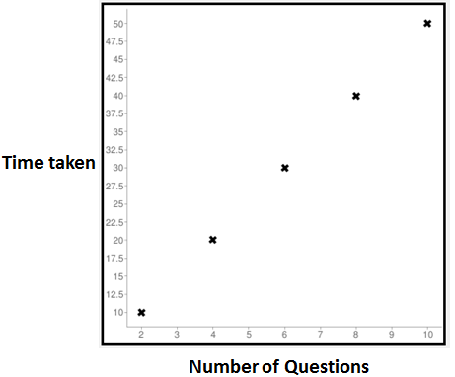

- Describe how the slope of a line relates to a trend line. What does the y-intercept represent?
The slope of a trend line is the average rate of change for the data. The y-intercept is the estimated value for x = 0.

- Graph the equation $y=\left|x\right|-1$ by translating the function $y=|x|$.
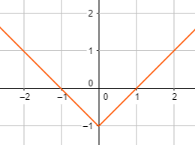

- Write the equation represented by the graph shown below.
$y=\left|x+1.5\right|$

- Graph the equation $y=-|x-2|$ by reflecting and translating the function $y=|x|$.
