- Identify from the graph the solution of the system and determine if it is an independent, Inconsistent or Dependent system.
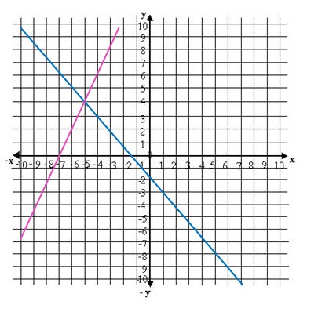

- Find the solution of the following system of equations by graphing.
$2x + y= 6$
$x + y= 5$

- Identify from the graph the solution of the system and determine if it is an independent, Inconsistent or Dependent system.
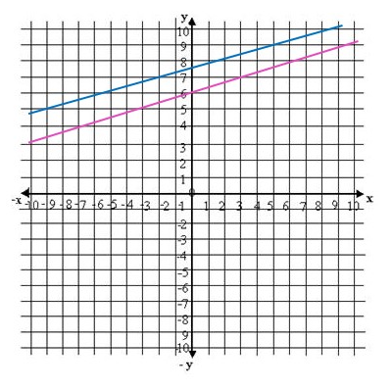

- Find the solution of the following system of equations by graphing.
$3x+5y=15$
$2x+2y=6$

- If the solution of two straight lines does not exist, the two lines are:
a. Concurrent
b. Perpendicular
c. Parallel
d. None of these

- Find the solution of the following system of equation by substitution and determine if it is an independent, inconsistent or dependent system.
$2x + y = 3$
$5x – 2y = 4$

- Find the solution of the following system of equation by substitution and determine if it is an independent, inconsistent or dependent system.
$7x + 2y = 16$
$-21x - 6y = 24$

- Find the solution of the following system of equation by substitution and determine if it is an independent, inconsistent or dependent system.
$-3x -2y = -12$
$y = 5x -7$

- The method in which we substitute the value of one variable from one equation to another is known as:
a. Elimination method
b. Substitution method
c. Graphing method
d. None of these
- The method in which we eliminate one variable from two equations to find the value of other variable is known as:
a. Elimination method
b. Substitution method
c. Graphing method
d. None of these

- Find the solution of the following systems by elimination and determine if it is an independent, inconsistent or dependent system.
$2x + y = 3$
$5x – 2y = 4$

- Find the solution of the following systems by elimination and determine if it is an independent, inconsistent or dependent system.
$7x + 2y = 16$
$-21x - 6y = 24$

- Find the solution of the following systems by elimination and determine if it is an independent, inconsistent or dependent system.
$4x -3y = 18$
$y + 2 = 0$

- A system of equations having no solution is known as:
a. Independent system
b. Inconsistent system
c. Dependent system
d. None of these

- Find the solution of the following systems by elimination and determine if it is an independent, inconsistent or dependent system.
$-3x + 3y = 4$
$–x + y= 3$

- The sum of two numbers is 13 and their difference is 5. Find the numbers.

- A flour merchant has two types of flours, one selling for $9 per pound and the other for $15 per pound. The flours are to be mixed to provide 100 lb of a mixture selling for $13.50 per pound. How much of each type of flour should be used to form 100 lb of the mixture?

- A chemist has a 40% and a 20% basic solution. How much of each solution should be used to form 300 ml of a 30% acid solution?

- The sum of 5 times a larger number and twice a smaller is 6. The difference of 4 times the larger and the smaller is 4. Find the numbers.

- A roll of 24 bills contains only $5 bills and $10 bills. If the value of the roll is $160, then how many of each bill are in the roll?

- Express the following interval as sets:
$\left[2 , 5\right]$

- Express the following set as intervals:
$\left\{x | x ∈R, 0≤ x≤4\right\}$

- Solve the following inequality and graph it:
$2x+1≤7$

- Solve the following inequality and graph it:
$\frac{3x-4}{2}>5$

- Solve the following inequality and graph it:
$9x+8≤3x-2$

- Solve the following inequalities and graph its solution:

$\left\{\begin{aligned}x+y≥0 \\ 2x-y≥0\end{aligned}\right.$

- Solve the following inequalities and graph its solution:

$\left\{\begin{aligned}3x+y≥0 \\ 2x+y≥0 \\ x≤2\end{aligned}\right.$

- Jessica works as an online tutor for $6 per hour. She also works as an editor for $3. She is allowed to work 30 hours per week and she wants to make at most $60. Write and graph a system of linear inequalities.

- Solve the following inequalities and graph its solution:

$\left\{\begin{aligned}y≥2x+1 \\ y≥-x+3\end{aligned}\right.$

- A system of inequalities has:
a. one point as solution
b. a region of solutions
c. no solution
d. None of these

ANSWERS
- Identify from the graph the solution of the system and determine if it is an independent, Inconsistent or Dependent system.
Solution (-5,4) , Independent System
- Find the solution of the following system of equations by graphing.
$2x + y= 6$
$x + y= 5$
$2x + y= 6$:
$x=0 →y=6 →\left(0,6\right)$
$y=0 →x=3 →(3,0)$
$x + y= 5$:
$x=0 →y=5→(0,5)$

$y=0 → x=5 →(5,0)$

Graph:

System Solution (1, 4)
- Identify from the graph the solution of the system and determine if it is an independent, Inconsistent or Dependent system.
No solution, Inconsistent System

- Find the solution of the following system of equations by graphing.
$3x+5y=15$
$2x+2y=6$
$3x+5y=15$:
$x=0 →y=3 →(0,3)$
$y=0 →x=5 →(5,0)$
$2x+2y=6$:
$x=0 →y=3 →(0,3)$
$y=0 →x=3 →(3,0)$
Graph:

System Solution (0, 3)
- If the solution of two straight lines does not exist, the two lines are:
a. Concurrent
b. Perpendicular
c. Parallel
d. None of these

- Find the solution of the following system of equation by substitution and determine if it is an independent, inconsistent or dependent system.
$2x + y = 3$
$5x – 2y = 4$
We choose the equation which contains the easiest variable to solve. In this case we select to solve variable “y” from equation I and then substitute it in equation II to find the value of the other variable, like follows:

$$y=3-2x$$
Substituting in II:
$5x-2\left(3-2x\right)$=4
Applying distributive property: $5x-6+4x=4 → 9x=10 → x=\frac{10}{9}$
Now, we calculate the value of variable “y” by substituting the result of x into the equation y =2 -3x
$$y=3-2\left(\frac{10}{9}\right)=\frac{7}{9}$$
Solution (10/9, 7/9). Independent System

- Find the solution of the following system of equation by substitution and determine if it is an independent, inconsistent or dependent system.
$7x + 2y = 16$
$-21x - 6y = 24$
We choose the equation which contains the easiest variable to solve. In this case, both are equally difficult to solve, so we can select any of them. We select variable “y” from equation I and then substitute it in equation II to find the value of the other variable, like follows:

$$y=\frac{16-7x}{2}$$
Substituting in II:
$-21x-6\left(\frac{16-7x}{2}\right)=24$
Applying distributive property: $-21x-48+21x=24 → 0=72$

No Solution. Inconsistent System
- Find the solution of the following system of equation by substitution and determine if it is an independent, inconsistent or dependent system.
$-3x -2y = -12$
$y = 5x -7$
We choose the equation which contains the easiest variable to solve. In this case we select to solve variable “y” from equation I and then substitute it in equation II to find the value of the other variable, like follows:

$$y=3-2x$$
Substituting in II:
$5x-2\left(3-2x\right)$=4
Applying distributive property: $5x-6+4x=4 → 9x=10 → x=\frac{10}{9}$

Now, we calculate the value of variable “y” by substituting the result of x into the equation y =2 -3x
$$y=3-2\left(\frac{10}{9}\right)=\frac{7}{9}$$
Solution (10/9, 7/9). Independent System

- The method in which we substitute the value of one variable from one equation to another is known as:
a. Elimination method
b. Substitution method
c. Graphing method
d. None of these
- The method in which we eliminate one variable from two equations to find the value of other variable is known as:
a. Elimination method
b. Substitution method
c. Graphing method
d. None of these

- Find the solution of the following systems by elimination and determine if it is an independent, inconsistent or dependent system.
$2x + y = 3$
$5x – 2y = 4$
We interchange the “x” or “y” coefficients from equation I and equation II to eliminate one of the variables. In this case, we are going to interchange the “x” coefficients of both equations, like follows:

$$\left\{\begin{aligned}-5(2x+y=3) \\ 2(5x-2y=4)\end{aligned}\right.$$
As both coefficients have the same sign, we have to assign a negative sign to one of the coefficients so they can eliminate each other
Applying distributive property: $$\left\{\begin{aligned}-10x-5y=-15 \\ 10x-4y=8\end{aligned}\right.$$
The result would be:
$$-9y=-7 →y=\frac{7}{9}$$

Now, we calculate the value of variable “x” by substituting the result of “y” into one of the equations
$$x=\frac{3-y}{2}=\frac{3-\frac{7}{9}}{2}=\frac{10}{9}$$
Solution (10/9, 7/9). Independent System

- Find the solution of the following systems by elimination and determine if it is an independent, inconsistent or dependent system.
$7x + 2y = 16$
$-21x - 6y = 24$
We interchange the “x” or “y” coefficients from equation I and equation II to eliminate one of the variables. In this case, we are going to interchange the “x” coefficients of both equations, like follows:

$$\left\{\begin{aligned}21(7x+2y=16) \\ 7(-21x-6y=24)\end{aligned}\right.$$
As both coefficients have different signs, we do not have to assign a negative sign to one of the coefficients so they can eliminate each other.
Applying distributive property: $$\left\{\begin{aligned}147x+42y=336 \\ -147x-42y=168\end{aligned}\right.$$
The result would be:
$$0=504$$

No Solution. Inconsistent System

- Find the solution of the following systems by elimination and determine if it is an independent, inconsistent or dependent system.
$4x -3y = 18$
$y + 2 = 0$
We interchange the “x” or “y” coefficients from equation I and equation II to eliminate one of the variables. In this case, we are going to interchange the “y” coefficients of both equations, like follows:

$$\left\{\begin{aligned}1(4x-3y=18) \\ 3(2+y=0)\end{aligned}\right.$$
As both coefficients have different signs, we do not have to assign a negative sign to one of the coefficients so they can eliminate each other.
Applying distributive property: $$\left\{\begin{aligned}4x-3y=18 \\ 6+3y=0\end{aligned}\right.$$
The result would be:
$$4x+6=18 →x=\frac{18-6}{4}=3$$

The value of y is calculated from equation II
$$2+y=0 →y=-2$$
Solution (3, -2). Independent System
- A system of equations having no solution is known as:
a. Independent system
b. Inconsistent system
c. Dependent system
d. None of these

- Find the solution of the following systems by elimination and determine if it is an independent, inconsistent or dependent system.
$-3x + 3y = 4$
$–x + y= 3$
We interchange the “x” or “y” coefficients from equation I and equation II to eliminate one of the variables. In this case, we are going to interchange the “x” coefficients of both equations, like follows:

$$\left\{\begin{aligned}-1(-3x+3y=4) \\ 3(-x+y=3)\end{aligned}\right.$$
As both coefficients have the same sign, we have to assign a negative sign to one of the coefficients so they can eliminate each other
Applying distributive property: $$\left\{\begin{aligned}3x-3y=-4 \\ -3x+3y=9\end{aligned}\right.$$
The result would be:
$$0=5$$

No Solution. Inconsistent System

- The sum of two numbers is 13 and their difference is 5. Find the numbers.

- Identify variables
x: First unknown number y: Second unknown number
- Set up equations

$$x+y=13 and x-y=5$$
- Solve linear System
In this case we will use the elimination method, like follows:

$$\left\{\begin{aligned}x+y=13 \\ x-y=5\end{aligned}\right.$$

The result would be:
$$2x=18 → x=\frac{18}{2}=9$$

Now, we calculate the value of variable “y” by substituting the result of “x” into one of the equations
$$y=13-x=13-9 → y=4$$

The numbers are 9 and 4

- A flour merchant has two types of flours, one selling for $9 per pound and the other for $15 per pound. The flours are to be mixed to provide 100 lb of a mixture selling for $13.50 per pound. How much of each type of flour should be used to form 100 lb of the mixture?

- Identify variables
x: Flour of $9 y: Flour of $15
- Set up equations

$$x+y=100 and 9x+15y=1350$$
- Solve linear System
In this case we will use the elimination method, like follows:

$$\left\{\begin{aligned}x+y=100 \\ 9x+15y=1350\end{aligned}\right.$$

We interchange the “x” or “y” coefficients from equation I and equation II to eliminate one of the variables. In this case, we are going to interchange the “x” coefficients of both equations, like follows:

$$\left\{\begin{aligned}-9(x+y=100) \\ 1(9x+15y=1350)\end{aligned}\right.$$
Applying distributive property: $$\left\{\begin{aligned}-9x-9y=-900 \\ 9x+15y=1350\end{aligned}\right.$$
The result would be:
$$6y=450 →y=75$$

Now, we calculate the value of variable “x” by substituting the result of “y” into one of the equations
$$x=100-y=100-75=25$$

It must be needed 25 lb of $9 flour and 75 lb of $15 flour.
- A chemist has a 40% and a 20% basic solution. How much of each solution should be used to form 300 ml of a 30% acid solution?

- Identify variables
x: 40% basic solution y: 20% basic solution
- Set up equations

$$x+y=300 and 0.40x+0.20y=0.30(300)$$
- Solve linear System
We will use the elimination method, like follows:

$$\left\{\begin{aligned}x+y=300 \\ 0.40x+0.20y=90\end{aligned} \right.$$

We interchange the “x” or “y” coefficients from equation I and equation II to eliminate one of the variables. In this case, we are going to interchange the “x” coefficients of both equations, like follows:

$$\left\{\begin{aligned}0.40(x+y=300) \\ -1(0.40x+0.20y=90)\end{aligned}\right.$$
Applying distributive property: $$\left\{\begin{aligned}0.40x+0.40y=120 \\ -0.40x-0.20y=-90\end{aligned}\right.$$
The result would be:
$$0.20y=30 →y=150$$

Now, we calculate the value of variable “x” by substituting the result of “y” into one of the equations
$$x=300-y=300-150=150$$

It must be needed 150 ml of 40% basic solution and 150 ml of 20% basic solution.

- The sum of 5 times a larger number and twice a smaller is 6. The difference of 4 times the larger and the smaller is 4. Find the numbers.

- Identify variables
x: Larger number y: Smaller number
- Set up equations

$$5x+2y=6 and 4x-y=4$$
- Solve linear System
We will use the elimination method, like follows:

$$\left\{\begin{aligned}5x+2y=6 \\ 4x-y=4\end{aligned}\right.$$

We interchange the “x” or “y” coefficients from equation I and equation II to eliminate one of the variables. In this case, we are going to interchange the “y” coefficients of both equations, like follows:

$$\left\{\begin{aligned}1(5x+2y=6) \\ 2(4x-y=4)\end{aligned}\right.$$
Applying distributive property: $$\left\{\begin{aligned}5x+2y=6 \\ 8x-2y=8\end{aligned}\right.$$
The result would be:
$$13x=14 → x=\frac{14}{13}$$

Now, we calculate the value of variable “y” by substituting the result of “x” into one of the equations
$$y=4x-4=4\left(\frac{14}{13}\right)-4=\frac{4}{13}$$

The larger number is 14/13 and the smaller number is 4/13.

- A roll of 24 bills contains only $5 bills and $10 bills. If the value of the roll is $160, then how many of each bill are in the roll?

- Identify variables
x: Number of $5 bills y: Number of $10 bills
- Set up equations

$$x+y=24 and 5x+10y=160$$
- Solve linear System
In this case we will use the elimination method, like follows:

$$\left\{\begin{aligned}x+y=24 \\ 5x+10y=160\end{aligned}\right.$$

We interchange the “x” or “y” coefficients from equation I and equation II to eliminate one of the variables. In this case, we are going to interchange the “x” coefficients of both equations, like follows:

$$\left\{\begin{aligned}5(x+y=24) \\ -1(5x+10y=160)\end{aligned}\right.$$
Applying distributive property: $$\left\{\begin{aligned}5x+5y=120 \\ -5x-10y=-160\end{aligned}\right.$$
The result would be:
$$-5y=-40 →y=8$$

Now, we calculate the value of variable “x” by substituting the result of “y” into one of the equations
$$x=24-y=24-8=16$$

There are 16 bills of $5 and 8 bills of $10.
- Express the following interval as sets:
$\left[2 , 5\right]$
All x such that x is greater than or equal to 2 and less or equal to 5.

$\left\{x | x ∈R, 2≤ x≤5\right\}$
- Express the following set as intervals:
$\left\{x | x ∈R, 0≤ x≤4\right\}$
$\left[0,\left.4\right]\right.$
- Solve the following inequality and graph it:
$2x+1≤7$

$2x≤7-1 → 2x≤6 → \frac{2x}{2}≤\frac{6}{2} → x≤3$

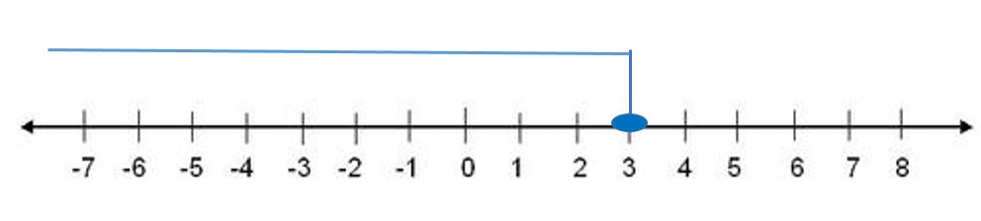

Solution:
$\left\{x | x ∈R, x≤3\right\}= \left(-∞,\right.\left.3\right]$

- Solve the following inequality and graph it:
$\frac{3x-4}{2}>5$
Multiplying by 2 both sides:

$$2×\left(\frac{3x-4}{2}\right)>2×5 → 3x-4>10 → 3x>14$$
Solving for x:
$$\frac{1}{3}\left(3x\right)>\frac{1}{3}\left(14\right) → x>\frac{14}{3}$$
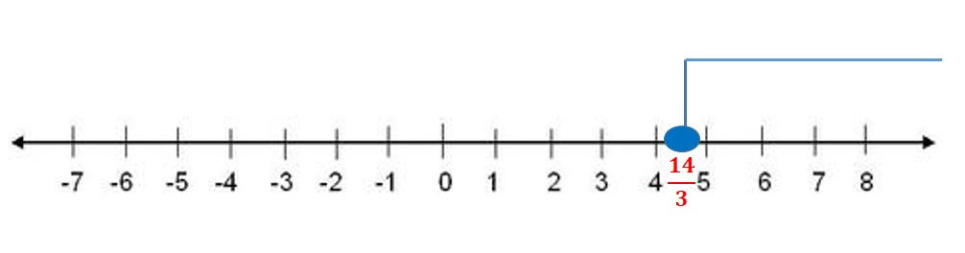
Solution:
$\left\{x | x ∈R, x>\frac{14}{3}\right\}= \left(\frac{14}{3}, ∞\right)$

- Solve the following inequality and graph it:
$9x+8≤3x-2$

$9x-3x≤-2-8 6x≤-10$

Multiplying by 6 both sides to solve for x:

$\frac{1}{6}\left(6x\right)≤\frac{1}{6}\left(-10\right) →simplifying x≤-\frac{5}{3}$
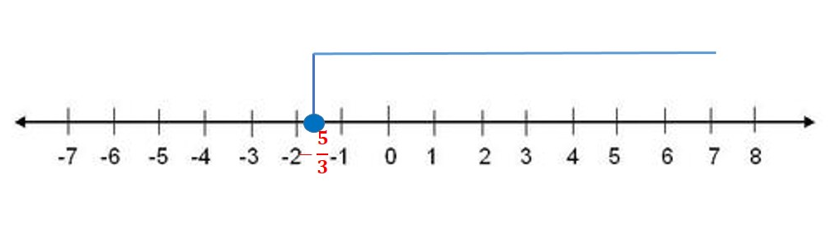

Solution:
$$\left\{x | x ∈R, x≤-\frac{5}{3}\right\}= \left(-∞,\right. \left.-\frac{5}{3}\right]$$

- Solve the following inequalities and graph its solution:

$\left\{\begin{aligned}x+y≥0 \\ 2x-y≥0\end{aligned}\right.$

We have to graph each of the linear function that compound the system. One easy way to graph each linear function is to find its intercepts with the axes.

- $y=-x$
$$x=0 →y=0 →(0,0)$$

$$y=2 →x=-2 →(-2,2)$$

- $y=2x$

$$x=0 →y=0 →(0,0)$$

$$y=2 →x=4 →(2,4)$$

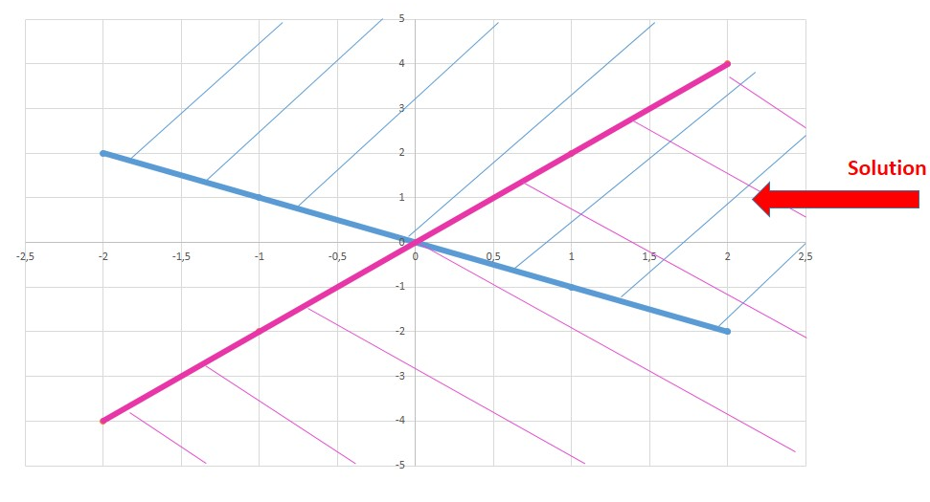

Proving with the point (1,1) that belongs to the solution region to verify if it satisfies the inequalities:

$1+1≥0 → 2>0$

$2\left(1\right)-1≥0 → 1>0$

- Solve the following inequalities and graph its solution:

$\left\{\begin{aligned}3x+y≥0 \\ 2x+y≥0 \\ x≤2\end{aligned}\right.$

We have to graph each of the linear function that compound the system. One easy way to graph each linear function is to find its intercepts with the axes.

- $y=-3x$
$$x=0 →y=0 →(0,0)$$

$$y=6 →x=-2 →(-2,6)$$

- $y=-2x$

$$x=0 →y=0 →(0,0)$$

$$y=4 →x=-2 →(-2,4)$$
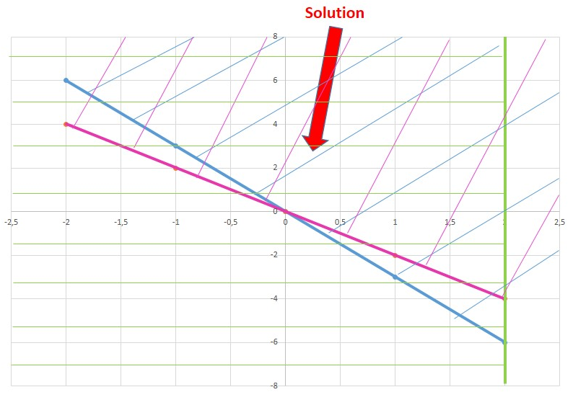

Proving with the point (1,2) that belongs to the solution region to verify if it satisfies the inequalities:

$$3(1)+2≥0 → 5>0$$

$$2\left(1\right)+2≥0 → 4>0$$

$$1<2$$

- Jessica works as an online tutor for $6 per hour. She also works as an editor for $3. She is allowed to work 30 hours per week and she wants to make at most $60. Write and graph a system of linear inequalities.

SOLUTION
Let´s define the variables that represent the system:

X= hours worked as online tutor
Y= Hours worked as editor

- As an online tutor she earns $6 per hour and as editor $3 to make at most $60, so the inequality is represented as follows:
$$6x+3y≤60 →simplifying →2x+y≤20$$

- She is allowed to works at most 30 hours, so:
$$x+y≤30$$

Finally we have the system:

$$\left\{\begin{aligned}y≤-2x+20 \\ y≤-x+30\end{aligned}\right.$$

We have to graph each of the linear function that compound the system. One easy way to graph each linear function is to find its intercepts with the axes.

- $y=-2x+20$
$$x=0 →y=20→(0, 20)$$

$$y=16 →x=2 →(2, 16)$$

- $y=-x+30$

$$x=0 →y=30 →(0, 30)$$

$$y=32 →x=-2 →(-2, 32)$$
Graphing:

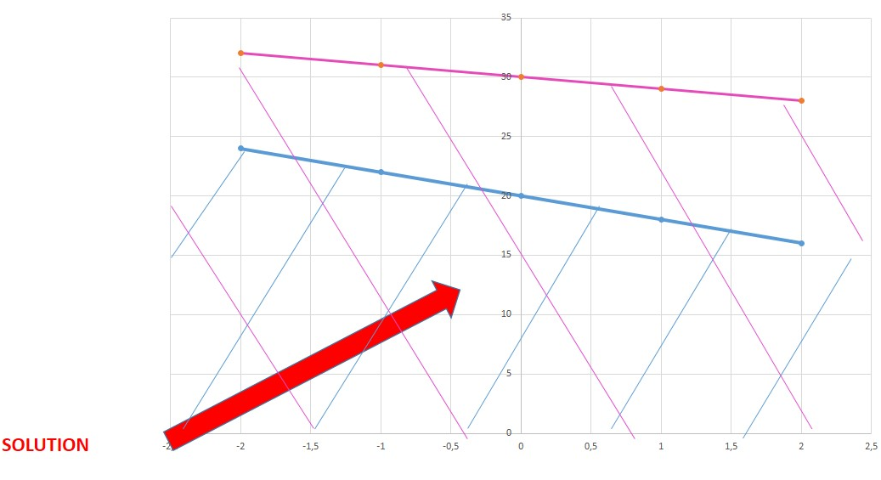
Proving with the point (1, 10) that belongs to the solution region to verify if it satisfies the inequalities:
$10≤-2\left(1\right)+20 → 10<18$

$10≤-1+30 → 10<29$

- Solve the following inequalities and graph its solution:

$\left\{\begin{aligned}y≥2x+1 \\ y≥-x+3\end{aligned}\right.$

We have to graph each of the linear function that compound the system. One easy way to graph each linear function is to find its intercepts with the axes.

- $y=2x+1$
$$x=0 →y=1→(0,1)$$

$$y=5 →x=2 →(2,5)$$

- $y=-x+3$

$$x=0 →y=3 →(0,3)$$

$$y=1 →x=2 →(2,1)$$

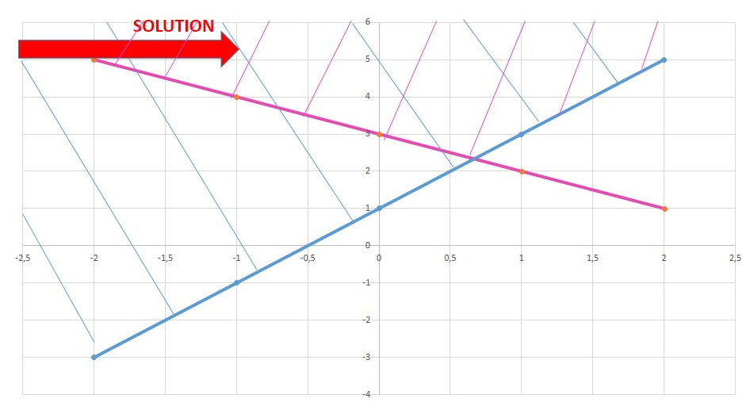

Proving with the point (1, 4) that belongs to the solution region to verify if it satisfies the inequalities:

$4≥2\left(1\right)+1 → 4>3$

$4≥-1+3 → 4>2$
- A system of inequalities has:
a. one point as solution
b. a region of solutions
c. no solution
d. None of these

