Identify from the graph the solution of the system and determine if it is an independent, inconsistent or dependent system
- 2.
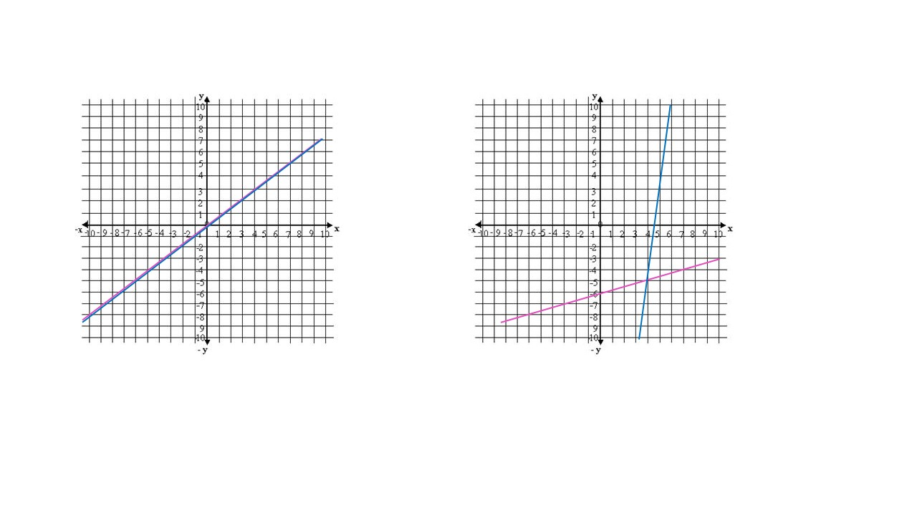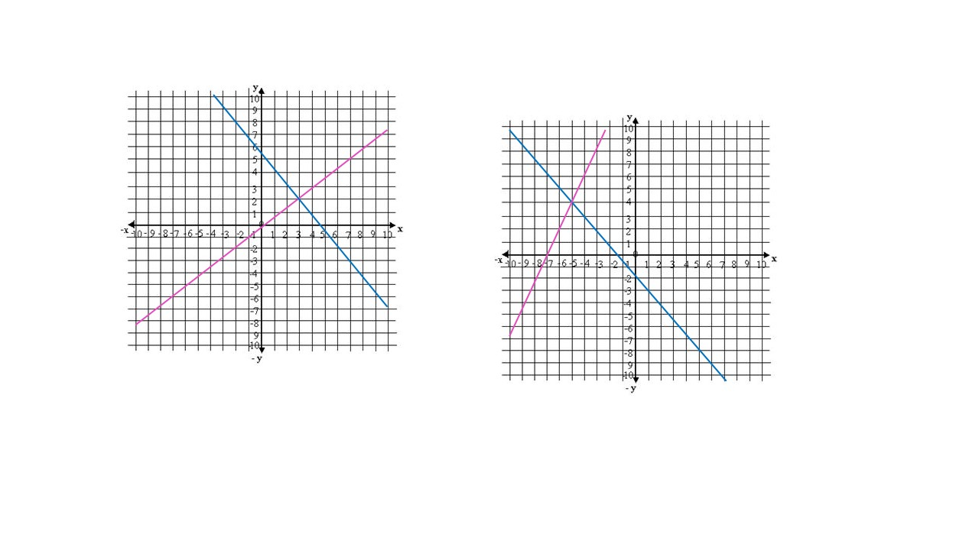

Find the solution of the following systems by graphing

3. $\left\{\begin{aligned}x+y=7 \\ 3x-y=-3\end{aligned}\right.$ 4. $\left\{\begin{aligned}x+4y=1 \\ 2x+y=5\end{aligned}\right.$

Find the solution of the following systems by substitution and determine if it is an independent, inconsistent or dependent system

5. $\left\{\begin{aligned}x=3y-1 \\ 3x-y=2\end{aligned}\right.$ 6. $\left\{\begin{aligned}4x-3y=18 \\ y+2=0\end{aligned}\right.$

7. $\left\{\begin{aligned}6x-y=3 \\ 5x-2y=-8\end{aligned}\right.$ 8. $\left\{\begin{aligned}x+y=4 \\ 5x-4y=6\end{aligned}\right.$

Find the solution of the following systems by elimination and determine if it is an independent, inconsistent or dependent system

9. $\left\{\begin{aligned}2x+3y=14 \\ x+2y=9\end{aligned}\right.$ 10. $\left\{\begin{aligned}5x-2y=1 \\ x+4y=8\end{aligned}\right.$

11. $\left\{\begin{aligned}x-y=10 \\ x+6y=1\end{aligned}\right.$ 12. $\left\{\begin{aligned}x+y=3 \\ 4x+3y=10\end{aligned}\right.$

Solve the following verbal problems involving linear systems:

13. One number is 3 less than 2 times another. If the sum of the numbers is 36, what are the numbers?

14. A sugar merchant has two types of sugar, one selling for $4 per pound and the other for $7 per pound. The sugars are to be mixed to provide 80 lb of a mixture selling for $12 per pound. How much of each type of sugar should be used to form 100 lb of the mixture?

15. The length of a rectangle is 5 cm less than two times its width. If the perimeter of the rectangle is 80 cm, which are the values of length and width?

16. Peter has a total investment of $7000 in two accounts. One account paying 5% interest and the other paying 8%. If the annual interest from the two investments was $500, how much did Anabel invest in each account?

Express the following intervals as sets

17. $\left[-3 , 8\right]$

18. $\left(2 , \left.7\right]\right.$

19. $\left[-1 , \left.5\right)\right.$

20. $\left(6 , \left.∞\right)\right.$

21. $\left(0 , \left.∞\right)\right.$

22. $\left(-∞,\left.4\right]\right.$

Solve the following inequalities and graph its solution

23. $4x+6≤2x+10$
24. $9x+8≤3x-2$
25. $6\left(2x-1\right)≥4\left(x+5\right)$
26. $x-4≤\frac{1}{2}$
27. $\frac{5x+2}{3}≥1$

Solve the following inequalities and graph its solution

28. $\left\{\begin{aligned}x+y≤4 \\ 3x+y≤6\end{aligned}\right.$

29. $\left\{\begin{aligned}4x+y<8 \\ -x+y≥2\end{aligned}\right.$

30. $\left\{\begin{aligned}2x+y≤6 \\ x+y≥0 \\ y≤4\end{aligned}\right.$

31. $\left\{\begin{aligned}y≥x+1 \\ y>2x\end{aligned}\right.$

Solve the following word problem:

- Karen works as an online tutor for $6 per hour. She also works as an editor for $3. She is allowed to work 30 hours per week and she wants to make at most $60. Write and graph a system of linear inequalities.

ANSWER

Identify from the graph the solution of the system and determine if it is an independent, inconsistent or dependent system

Remember the solution will be the point of intersection between both linear functions.
- Solution (4,-5) , Independent System
- Solution (3,2) , Independent System

Find the solution of the following systems by graphing

3. $\left\{\begin{aligned}x+y=7 \\ 3x-y=-3\end{aligned}\right.$

One easy way to graph each linear function is to find its intercepts with the axes.

- $x+y=7$
$$x=0 →y=7 →(0,7)$$

$$y=0 →x=7 →(7,0)$$

$3x-y=-3$
$$x=0 →y=3→(0,3)$$

$$y=0 → x=-1→(-1,0)$$

4. $\left\{\begin{aligned}x+4y=1 \\ 2x+y=5\end{aligned}\right.$

One easy way to graph each linear function is to find its intercepts with the axes.

- $x+4y=1$

$$x=0 →y=1/4→(0,\frac{1}{4})$$

$$y=0 → x=1 →(1,0)$$

$2x+y=-5$

$$x=0 →y=-5→(0, -5)$$

$$y=0 → x=-5/2 →(-\frac{5}{2},0)$$

System Solution (-3, 1)

Find the solution of the following systems by substitution and determine if it is an independent, inconsistent or dependent system

5. $\left\{\begin{aligned}x=3y-1 \\ 3x-y=2\end{aligned}\right.$

I. x = 3y - 1 and II. 3x - y = 2

We choose the equation which contains the easiest variable to solve. In this case we select variable “x” from equation I and then substitute it in equation II to find the value of the other variable, like follows:

$$x=3y-1$$

Substituting in II:
$$3\left(3y-1\right)-y=2$$
Applying distributive property: $9y-3-y=2 →8y=5 →y=5/8$

Now, we calculate the value of variable “x” by substituting the result of y into the equation x = 3y-1
$$x=3\left(\frac{5}{8}\right)-1=\frac{7}{8}$$
Solution (7/8, 5/8). Independent System

6. $\left\{\begin{aligned}4x-3y=18 \\ y+2=0\end{aligned}\right.$

I. 4x -3 y = 18 and II. y + 2 = 0

We choose the equation which contains the easiest variable to solve. In this case we select to solve variable “y” from equation II and then substitute it in equation I to find the value of the other variable, like follows:

$$y=-2$$

Substituting in I:
$$4x-3\left(-2\right)=18 →4x+6=18 →x=3$$

Solution (3, -2). Independent System

7. $\left\{\begin{aligned}6x-y=3 \\ 5x-2y=-8\end{aligned}\right.$

I. 6x - y = 3 and II. 5x – 2y = -8

We choose the equation which contains the easiest variable to solve. In this case we select to solve variable “y” from equation I and then substitute it in equation II to find the value of the other variable, like follows:

$$y=6x-3$$

Substituting in II:
$$5x-2\left(6x-3\right)=-8$$
Applying distributive property: $5x-12x+6=-8 → -7x=-14 → x=2$

Now, we calculate the value of variable “y” by substituting the result of “x” into the equation y= 6x - 3
$$y=6\left(2\right)-3=9$$
Solution (2, 9). Independent System

8. $\left\{\begin{aligned}x+y=4 \\ 5x-4y=6\end{aligned}\right.$

I. x + y = 4 and II. 5x – 4y = 6

We choose the equation which contains the easiest variable to solve. In this case we select to solve variable “x” from equation I and then substitute it in equation II to find the value of the other variable, like follows:

$$x=4-y$$

Substituting in II:
$$5\left(4-y\right)-4y=6$$
Applying distributive property: $20-5y-4y=6 → 9y=14→ y=\frac{14}{9}$

Now, we calculate the value of variable “x” by substituting the result of “y” into the equation x = 4 - y
$$x=4-\frac{14}{9}=\frac{22}{9}$$
Solution (22/9, 14/9). Independent System

Find the solution of the following systems by elimination and determine if it is an independent, inconsistent or dependent system

9. $\left\{\begin{aligned}2x+3y=14 \\ x+2y=9\end{aligned}\right.$

I. 2x +3 y = 14 and II. x + 2y = 9

We interchange the “x” or “y” coefficients from equation I and equation II to eliminate one of the variables. In this case, we are going to interchange the “y” coefficients of both equations, like follows:

$$\left\{\begin{aligned}-2(2x+3y=14) \\ 3(x+2y=9)\end{aligned}\right.$$
As both coefficients have the same sign, we have to assign a negative sign to one of the coefficients so they can eliminate each other
Applying distributive property: $$\left\{\begin{aligned}-4x-6y=-28 \\ 3x+6y=27\end{aligned}\right.$$
The result would be:
$$-x=-1 →x=1$$

Now, we calculate the value of variable “y” by substituting the result of “x” into one of the equations
$$y=\frac{9-x}{2}=\frac{9-1}{2}=4$$

Solution (1, 4). Independent System

10. $\left\{\begin{aligned}5x-2y=1 \\ x+4y=8\end{aligned}\right.$

I. 5x - 2y = 1 and II. x + 4y = 8

We interchange the “x” or “y” coefficients from equation I and equation II to eliminate one of the variables. In this case, we are going to interchange the “x” coefficients of both equations, like follows:

$$\left\{\begin{aligned}1(5x-2y=1) \\ -5(x+4y=8)\end{aligned}\right.$$
As both coefficients have the same sign, we have to assign a negative sign to one of the coefficients so they can eliminate each other.
Applying distributive property: $$\left\{\begin{aligned}5x-2y=1 \\ -5x-20y=-40\end{aligned}\right.$$
The result would be:
$$-22y=-39 →y=\frac{39}{22}$$

Now, we calculate the value of variable “x” by substituting the result of “y” into one of the equations
$$x=\frac{1+2y}{5}=\frac{1+2\left(\frac{39}{22}\right)}{5}=\frac{10}{11}$$

Solution (10/11, 39/22). Independent System

11. $\left\{\begin{aligned}x-y=10 \\ x+6y=1\end{aligned}\right.$

I. x - y = 10 and II. x + 6y = 1

We interchange the “x” or “y” coefficients from equation I and equation II to eliminate one of the variables. In this case, we are going to interchange the “x” coefficients of both equations, like follows:

$$\left\{\begin{aligned}1(x-y=10) \\ - 1(x+6y=1)\end{aligned}\right.$$
As both coefficients have equal signs, we have to assign a negative sign to one of the coefficients so they can eliminate each other.
Applying distributive property: $$\left\{\begin{aligned}x-y=10 \\ -x-6y=-1\end{aligned}\right.$$
The result would be:
$$-7y=9 →y=-\frac{9}{7}$$

Now, we calculate the value of variable “x” by substituting the result of “y” into the equation x = 10 + y
$$x=10-\frac{9}{7}=\frac{61}{7}$$
Solution (61/7, -9/7). Independent System

12. $\left\{\begin{aligned}x+y=3 \\ 4x+3y=10\end{aligned}\right.$

I. x + y = 3 and II. 4x + 3y = 10

We interchange the “x” or “y” coefficients from equation I and equation II to eliminate one of the variables. In this case, we are going to interchange the “y” coefficients of both equations, like follows:

$$\left\{\begin{aligned}3(x+y=3) \\ - 1(4x+3y=10)\end{aligned}\right.$$
As both coefficients have equal signs, we have to assign a negative sign to one of the coefficients so they can eliminate each other.
Applying distributive property: $$\left\{\begin{aligned}3x+3y=9 \\ -4x-3y=-10\end{aligned}\right.$$
The result would be:
$$-x=-1 →x=1$$

Now, we calculate the value of variable “y” by substituting the result of x into the equation y =3-x
$$y=3-1=2$$
Solution (1, 2). Independent System

Solve the following verbal problems involving linear systems:

13. One number is 3 less than 2 times another. If the sum of the numbers is 36, what are the numbers?

- Identify variables
x: First unknown number y: Second unknown number
- Set up equations

$$x+y=36 (I) and y=2x-3 (II)$$
- Solve linear System
We will use the substitution method, like follows:

$$\left\{\begin{aligned}x+y=36 \\ y=2x-3\end{aligned}\right.$$

Substituting equation II in equation I and then solve the equation.
$$x+2x-3=36 → 3x=39 →x=13$$

Now, we calculate the value of variable “y” by substituting the result of “x” into one of the equations
$$y=36-x=36-13=23$$

The numbers are 13 and 23

14. A sugar merchant has two types of sugar, one selling for $4 per pound and the other for $7 per pound. The sugars are to be mixed to provide 80 lb of a mixture selling for $12 per pound. How much of each type of sugar should be used to form 100 lb of the mixture?

- Identify variables
x: Sugar of $9 y: Sugar of $15
- Set up equations

$$x+y=100 and 9x+15y=1350$$
- Solve linear System
In this case we will use the elimination method, like follows:

$$\left\{\begin{aligned}x+y=100 \\ 9x+15y=1350\end{aligned}\right.$$

We interchange the “x” or “y” coefficients from equation I and equation II to eliminate one of the variables. In this case, we are going to interchange the “x” coefficients of both equations, like follows:

$$\left\{\begin{aligned}-9(x+y=100) \\ 1(9x+15y=1350)\end{aligned}\right.$$
Applying distributive property: $$\left\{\begin{aligned}-9x-9y=-900 \\ 9x+15y=1350\end{aligned}\right.$$
The result would be:
$$6y=450 →y=75$$

Now, we calculate the value of variable “x” by substituting the result of “y” into one of the equations
$$x=100-y=100-75=25$$

It must be needed 25 lb of $9 sugar and 75 lb of $15 sugar.

15. The length of a rectangle is 5 cm less than two times its width. If the perimeter of the rectangle is 80 cm, which are the values of length and width?

- Identify variables
x: Length y: Width

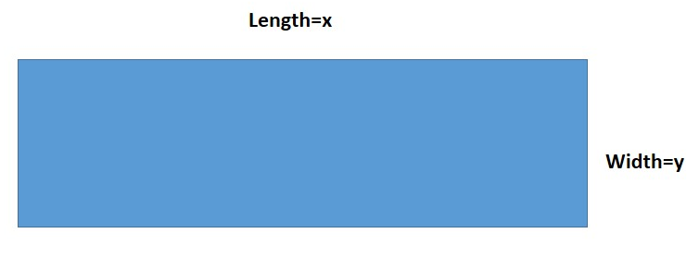

- Set up equations

$$x=2y-5 (I) and 2x+2y=80→ x+y=40 (II)$$

- Solve linear System
We will substitute equation I in II and solve for “y”

$$2y-5+y=40 →3y=45 →y=15$$

Now, we calculate the value of variable “x” by substituting the result of “y” into one of the equations
$$x=40-y=40-15=25$$

The length of the rectangle is 25 cm and its width is 15 cm.

16. Peter has a total investment of $7000 in two accounts. One account paying 5% interest and the other paying 8%. If the annual interest from the two investments was $500, how much did Anabel invest in each account?

- Identify variables
x: Amount invested at 5% y: Amount invested at 8%
- Set up equations

$$x+y=7000 and 0.05x+0.08y=500$$
- Solve linear System
We will use the elimination method, like follows:

$$\left\{\begin{aligned}x+y=7000 \\ 0.05x+0.08y=500\end{aligned}\right.$$

We interchange the “x” or “y” coefficients from equation I and equation II to eliminate one of the variables. In this case, we are going to interchange the “x” coefficients of both equations, like follows:

$$\left\{\begin{aligned}0.05(x+y=7000) \\ -1 (0.05x+0.08y=500)\end{aligned}\right.$$
Applying distributive property: $$\left\{\begin{aligned}0.05x+0.05y=350 \\ -0.05x-0.08y=-500\end{aligned}\right.$$
The result would be:
$$-0.03y=-150 →y=5000$$

Now, we calculate the value of variable “x” by substituting the result of “y” into one of the equations
$$x=7000-y=7000-5000=2000$$

Peter invested $2000 in the account at 5% and $5000 in the account at 8%.

Express the following intervals as sets

Remember that: $≤, ≥ are represented with \left[a, b\right]$
$<, > are represented with \left(a,b\right)$

$$17. \left[-3 , 8\right]$$

All x such that x is greater than or equal to -3 and less or equal to 8.

$$\left\{x | x ∈R, -3≤ x≤8\right\}$$

$$18. \left(2 , \left.7\right]\right.$$

All x such that x is greater than 2 and less or equal to 7.

$$\left\{x | x ∈R, 2< x≤7\right\}$$

$$19. \left[-1 , \left.5\right)\right.$$

All x such that x is greater than or equal to -1 and less than 5.

$$\left\{x | x ∈R,- 1≤ x<5\right\}$$

20. $\left(6 , \left.∞\right)\right.$

All x such that x is greater than 6

$$\left\{x | x ∈R, x>6\right\}$$

21. $\left(0 , \left.∞\right)\right.$

All x such that x is greater than 0

$$\left\{x | x ∈R, x>0\right\}$$

22. $\left(-∞ , \left. 4\right]\right.$

$$\left\{x | x ∈R, x≤4\right\}$$

Solve the following inequalities and graph its solution

23. $4x+6≤2x+10$

$$4x-2x≤10-6 → 2x ≤4 →\frac{1}{2}\left(2x\right)≤\frac{1}{2}\left(4\right) → x≤2$$

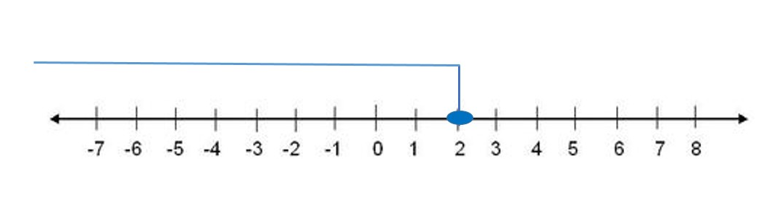
Solution: $$\left\{x | x ∈R, x≤2\right\}= \left(-∞,\left.2\right]\right.$$

24. $9x+8≤3x-2$

$$9x-3x≤-2-8 6x≤-10$$

Multiplying by 6 both sides to solve for x:

$\frac{1}{6}\left(6x\right)≤\frac{1}{6}\left(-10\right) →simplifying x≤-\frac{5}{3}$

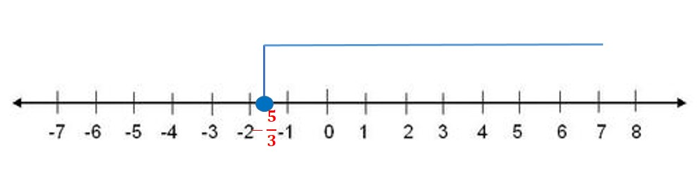

Solution:
$$\left\{x | x ∈R, x≤-\frac{5}{3}\right\}= \left(-∞,\right. \left.-\frac{5}{3}\right]$$

25. $6\left(2x-1\right)≥4\left(x+5\right)$

Applying distributive property:

$$12x-6≥4x+20 → 12x-4x≥20+6 → 8x≥26$$

Solving for x:
$$\frac{1}{8}\left(8x\right)≥\frac{1}{8}\left(26\right) → simplifying x≥ \frac{13}{4}$$

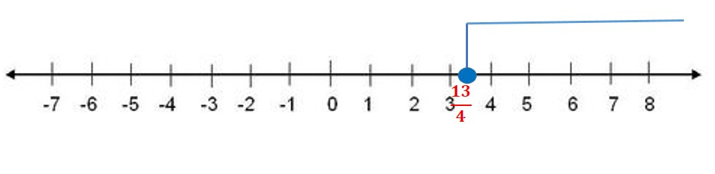

Solution:
$$\left\{x | x ∈R, x≥\frac{13}{4}\right\}= \left[\frac{13}{4},\left.∞\right)\right.$$

26. $x-4≤\frac{1}{2}$

Solving for x:

$$x-4≤\frac{1}{2} → x≤\frac{1}{2}+4 → x≤\frac{9}{2}$$

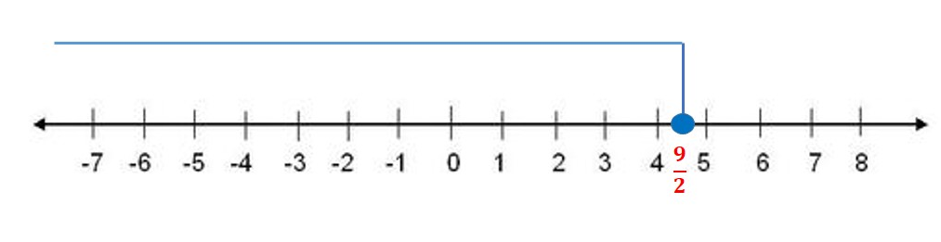

Solution:
$$\left\{x | x ∈R, x≤\frac{9}{2}\right\}=(-∞, \left.\frac{9}{2}\right]$$

27. $\frac{5x+2}{3}≥1$

$3(\frac{5x+2}{3})≥3(1)$
Solving for x:

$5x+2≥3 → simplifying 5x≥3-2$

$$\frac{1}{5}\left(5x\right)≥\frac{1}{5}\left(1\right) → x≥\frac{1}{5}$$

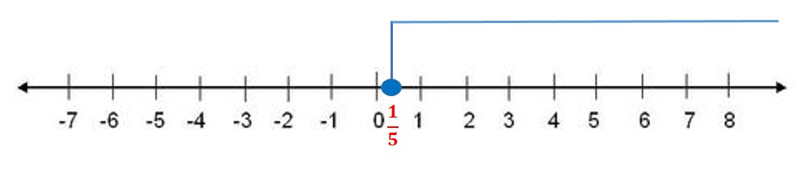

Solution:
$$\left\{x | x ∈R, x≥\frac{1}{5}\right\}= \left[\frac{1}{5},\right.\left.∞\right)$$

Solve the following inequalities and graph its solution

28. $\left\{\begin{aligned}x+y≤4 \\ 3x+y≤6\end{aligned}\right.$

We have to graph each of the linear function that compound the system. One easy way to graph each linear function is to find its intercepts with the axes.

- $y=-x+4$
$$x=0 →y=4 →(0,4)$$

$$y=2 →x=2 →(2,2)$$

- $y=-3x+6$

$$x=0 →y=6 →(0,6)$$

$$y=0 →x=2 →(2,0)$$

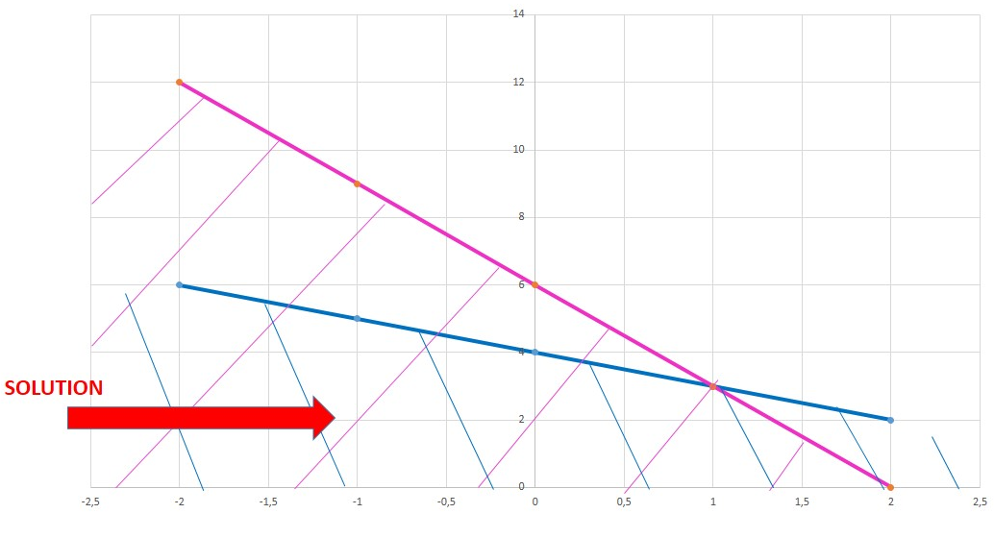

Proving with the point (0, 2) that belongs to the solution region to verify if it satisfies the inequalities:

$$2≤-0+4 → 2<4$$

$$2<-3(0)+6 → 2<6$$

29. $\left\{\begin{aligned}4x+y<8 \\ -x+y≥2\end{aligned}\right.$

We have to graph each of the linear function that compound the system. One easy way to graph each linear function is to find its intercepts with the axes.

- $y=-4x+8$
$$x=0 →y=8 →(0,8)$$

$$y=0 →x=2 →(2,0)$$

- $y=x+2$

$$x=0 →y=2 →(0,2)$$

$$y=0 →x=-2 →(-2,0)$$

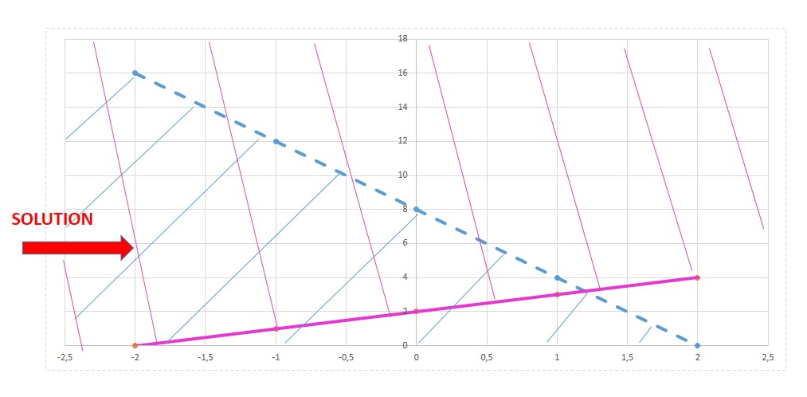
The segmented line is because the border of the line does not belong to the solution and the straight line is because the border of the line belongs to the solution.
Proving with the point (-1,4) that belongs to the solution region to verify if it satisfies the inequalities:

$$y<-4x+8 → 4<-4\left(-1\right)+8 → 4<12$$

$$y≥x+2 →4≥-1+2 → 4>1$$

30. $\left\{\begin{aligned}2x+y≤6 \\ x+y≥0 \\ y≤4\end{aligned}\right.$

We have to graph each of the linear function that compound the system. One easy way to graph each linear function is to find its intercepts with the axes.

- $y=-2x+6$
$$x=0 →y=6→(0,6)$$

$$y=2 →x=2 →(2,2)$$

- $y=-x$

$$x=0 →y=0 →(0,0)$$

$$y=2 →x=-2 →(-2,2)$$

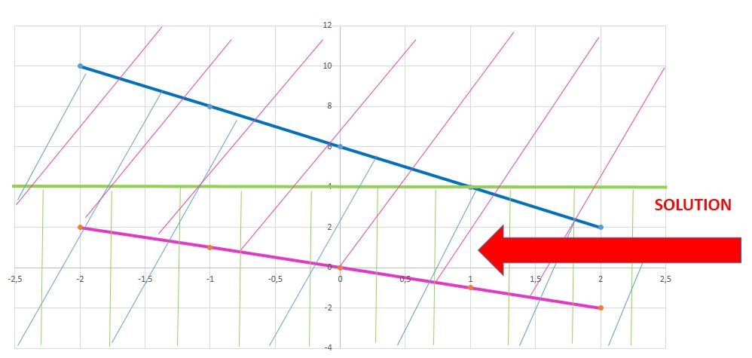

Proving with the point (1,2) that belongs to the solution region to verify if it satisfies the inequalities:

$$2x+y≤6 → 2\left(1\right)+2≤6 →4<6$$

$$x+y≥0 → 1+2≥0 →3≥0$$

$$y≤4 → 2≤4$$

31. $\left\{\begin{aligned}y≥x+1 \\ y>2x\end{aligned}\right.$

We have to graph each of the linear function that compound the system. One easy way to graph each linear function is to find its intercepts with the axes.

- $y=x+1$
$$x=0 →y=1 →(0,1)$$

$$y=0 →x=-1 →(-1,0)$$

- $y=2x$
$$x=0 →y=0 →(0,0)$$

$$y=4→x=2 →(2,4)$$

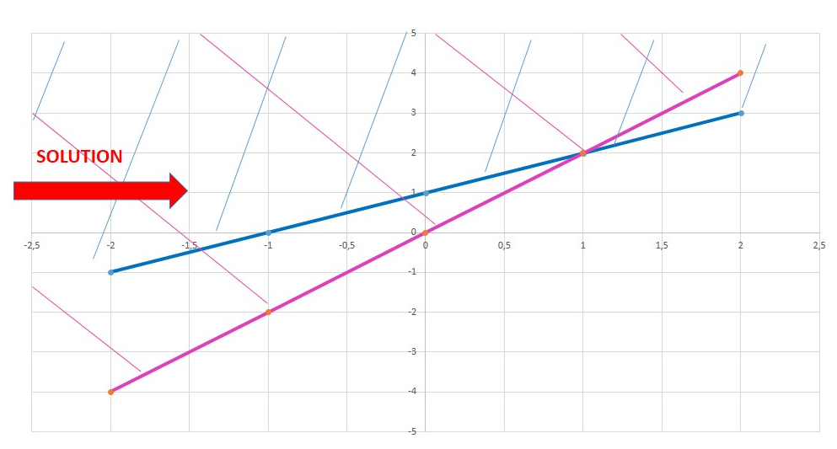

Proving with the point (-1,2) that belongs to the solution region to verify if it satisfies the inequalities:

$$y≥x+1 → 2≥-1+1 → 2≥0$$

$$y≥2x → 2≥2\left(-1\right) →2>-2$$

Solve the following word problem:
- Karen works as an online tutor for $6 per hour. She also works as an editor for $3. She is allowed to work 30 hours per week and she wants to make at most $60. Write and graph a system of linear inequalities.

SOLUTION
Let´s define the variables that represent the system:

X= hours worked as online tutor
Y= Hours worked as editor

- As an online tutor she earns $6 per hour and as editor $3 to make at most $60, so the inequality is represented as follows:
$$6x+3y≤60 →simplifying →2x+y≤20$$

- She is allowed to works at most 30 hours, so:
$$x+y≤30$$

Finally we have the system:

$$\left\{\begin{aligned}y≤-2x+20 \\ y≤-x+30\end{aligned}\right.$$

We have to graph each of the linear function that compound the system. One easy way to graph each linear function is to find its intercepts with the axes.

- $y=-2x+20$
$$x=0 →y=20→(0, 20)$$

$$y=16 →x=2 →(2, 16)$$

- $y=-x+30$

$$x=0 →y=30 →(0, 30)$$

$$y=32 →x=-2 →(-2, 32)$$
Graphing:

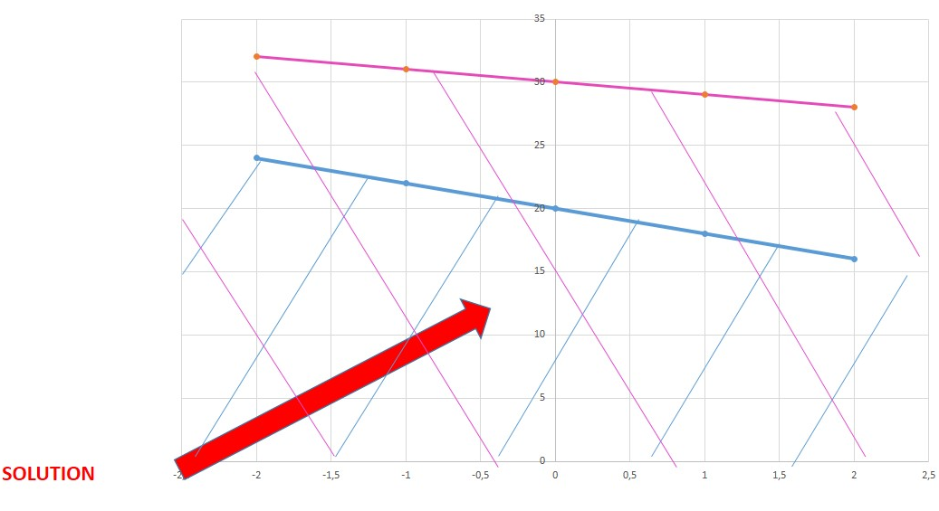

Proving with the point (1, 10) that belongs to the solution region to verify if it satisfies the inequalities:

$$10≤-2\left(1\right)+20 → 10<18$$

$$10≤-1+30 → 10<29$$

