- Identify from the graph the solution of the system and determine if it is an independent, Inconsistent or Dependent system.
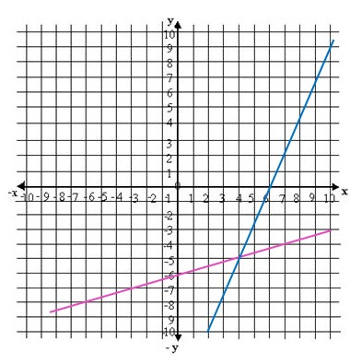

- Find the solution of the following system of equations by graphing.
$x+4y=1$
$2x+y=-5$

- If two or more lines meet each other at one and only one point, the lines are called:
a. Concurrent
b. Perpendicular
c. Parallel
d. None of these
- Find the solution of the following system of equation by substitution and determine if it is an independent, inconsistent or dependent system.
$x = 3y - 1$
$3x - y = 2$
- Find the solution of the following system of equation by substitution and determine if it is an independent, inconsistent or dependent system.
$2x + 4y = -6$
$3x - y = 2$

- The method in which we substitute the value of one variable from one equation to another is known as:
a. Elimination method
b. Substitution method
c. Graphing method
d. None of these
- Find the solution of the following systems by elimination and determine if it is an independent, inconsistent or dependent system.
$2x + 4y = -6$
$x = 1 -2y$

- Find the solution of the following systems by elimination and determine if it is an independent, inconsistent or dependent system.
$5x - 2y = 1$
$x + 4y = 8$

- A system of equations having exactly one solution is known as:
a. Independent system
b. Inconsistent system
c. Dependent system
d. None of these
- A total of $5500 was invested in two accounts. Part was invested in a CD at 2% annual interest rate and part was invested in a money market fund at 1% annual interest rate. If the total simple interest for one year was $100, then how much was invested in each account?

- Mary traveled a total of 10 hours and a total of 1850 miles by car and by plane. Driving to the airport by car, she averaged 50 miles per hour. In the air, the plane averaged 300 miles per hour. How long did it take her to drive to the airport?

- 800 tickets were sold for a Rock Music Concert with a total revenue of $7500. If adult tickets were sold for $12 and students tickets were sold for $8. How many of each type of ticket were sold?

- Express the following interval as sets:
$\left(2 , \left.10\right)\right.$

- Express the following set as intervals:
$\left\{x | x ∈R, 0≤ x≤4\right\}$
- Solve the following inequality and graph it
$4x+6≤2x+10$

- Solve the following inequality and graph it:
$2\left(x-4\right)>x-3$

- Solve the following inequalities and graph its solution:

$\left\{\begin{aligned}3x+y≥0 \\ 2x+y≥0 \\ x≤2\end{aligned}\right.$

- Jessica works as an online tutor for $6 per hour. She also works as an editor for $3. She is allowed to work 30 hours per week and she wants to make at most $60. Write and graph a system of linear inequalities.

- A system of inequalities has:
a. one point as solution
b. a region of solutions
c. no solution
d. None of these

- Solve the following inequalities and graph its solution:

$\left\{\begin{aligned}y≥2x+1 \\ y≥-x+3\end{aligned}\right.$

ANSWERS:
- Identify from the graph the solution of the system and determine if it is an independent, Inconsistent or Dependent system.
Solution (4,-5) , Independent System

- Find the solution of the following system of equations by graphing.
$x+4y=1$
$2x+y=-5$
$x+4y=1$:
$x=0 →y=1/4→(0,\frac{1}{4})$
$y=0 → x=1 →(1,0)$
$2x+y=-5$:
$x=0 →y=-5→(0, -5)$

$y=0 → x=-5/2 →\left(-\frac{5}{2},0\right)$

Graph:

System Solution (-3, 1)
- If two or more lines meet each other at one and only one point, the lines are called:
a. Concurrent
b. Perpendicular
c. Parallel
d. None of these
- Find the solution of the following system of equation by substitution and determine if it is an independent, inconsistent or dependent system.
$x = 3y - 1$
$3x - y = 2$
We choose the equation which contains the easiest variable to solve. In this case we select variable “x” from equation I and then substitute it in equation II to find the value of the other variable, like follows:
$$x=3y-1$$

Substituting in II:
$$3\left(3y-1\right)-y=2$$
Applying distributive property: $9y-3-y=2 →8y=5 →y=5/8$

Now, we calculate the value of variable “x” by substituting the result of y into the equation x = 3y-1
$$x=3\left(\frac{5}{8}\right)-1=\frac{7}{8}$$
Solution (7/8, 5/8). Independent System
- Find the solution of the following system of equation by substitution and determine if it is an independent, inconsistent or dependent system.
$2x + 4y = -6$
$3x - y = 2$
We choose the equation which contains the easiest variable to solve. In this case we select to solve variable “x” from equation II and then substitute it in equation I to find the value of the other variable, like follows:

$$x=1-2y$$

Substituting in I:
$$2\left(1-2y\right)+4y=-6$$
Applying distributive property: $2-4y+4y=-6 → 0=-6$

No Solution. Inconsistent System

- The method in which we substitute the value of one variable from one equation to another is known as:
a. Elimination method
b. Substitution method
c. Graphing method
d. None of these
- Find the solution of the following systems by elimination and determine if it is an independent, inconsistent or dependent system.
$2x + 4y = -6$
$x = 1 -2y$
We interchange the “x” or “y” coefficients from equation I and equation II to eliminate one of the variables. In this case, we are going to interchange the “x” coefficients of both equations, like follows:

$$\left\{\begin{aligned}1(2x+4y=-6) \\ -2(x+2y=1)\end{aligned}\right.$$
As both coefficients have the same sign, we have to assign a negative sign to one of the coefficients so they can eliminate each other
Applying distributive property: $$\left\{\begin{aligned}2x+4y=-6 \\ -2x-4y=-2\end{aligned}\right.$$
The result would be:
$$0=-8$$

No Solution. Inconsistent System
- Find the solution of the following systems by elimination and determine if it is an independent, inconsistent or dependent system.
$5x - 2y = 1$
$x + 4y = 8$
We interchange the “x” or “y” coefficients from equation I and equation II to eliminate one of the variables. In this case, we are going to interchange the “x” coefficients of both equations, like follows:

$$\left\{\begin{aligned}1(5x-2y=1) \\ -5(x+4y=8)\end{aligned}\right.$$
As both coefficients have the same sign, we have to assign a negative sign to one of the coefficients so they can eliminate each other.
Applying distributive property: $$\left\{\begin{aligned}5x-2y=1 \\ -5x-20y=-40\end{aligned}\right.$$
The result would be:
$$-22y=-39 →y=\frac{39}{22}$$

Now, we calculate the value of variable “x” by substituting the result of “y” into one of the equations
$$x=\frac{1+2y}{5}=\frac{1+2\left(\frac{39}{22}\right)}{5}=\frac{10}{11}$$

Solution (10/11, 39/22). Independent System

- A system of equations having exactly one solution is known as:
a. Independent system
b. Inconsistent system
c. Dependent system
d. None of these
- A total of $5500 was invested in two accounts. Part was invested in a CD at 2% annual interest rate and part was invested in a money market fund at 1% annual interest rate. If the total simple interest for one year was $100, then how much was invested in each account?

- Identify variables
x: Amount invested at 2% y: Amount invested at 1%
- Set up equations

$$x+y=5500 and 0.02x+0.01y=100$$
- Solve linear System
We will use the elimination method, like follows:

$$\left\{\begin{aligned}x+y=5500 \\ 0.02x+0.01y=100\end{aligned}\right.$$

We interchange the “x” or “y” coefficients from equation I and equation II to eliminate one of the variables. In this case, we are going to interchange the “x” coefficients of both equations, like follows:

$$\left\{\begin{aligned}0.02(x+y=5500) \\ -1(0.02x+0.01y=100)\end{aligned}\right.$$
Applying distributive property: $$\left\{\begin{aligned}0.02x+0.02=110 \\ -0.02x-0.01y=-100\end{aligned}\right.$$
The result would be:
$$0.01y=10 →y=1000$$

Now, we calculate the value of variable “x” by substituting the result of “y” into one of the equations
$$x=5500-y=5500-1000=4500$$

It was invested $4500 in the account at 2% and $1000 in the account of 1%.
- Mary traveled a total of 10 hours and a total of 1850 miles by car and by plane. Driving to the airport by car, she averaged 50 miles per hour. In the air, the plane averaged 300 miles per hour. How long did it take her to drive to the airport?

- Identify variables
x: Time driving to the airport y: Time spent in the air
- Set up equations

$$50x+300y=1850 and x+y=10$$
- Solve linear System
In this case we will use the elimination method, like follows:

$$\left\{\begin{aligned}x+y=10 \\ 50x+300y=1850\end{aligned}\right.$$

We interchange the “x” or “y” coefficients from equation I and equation II to eliminate one of the variables. In this case, we are going to interchange the “x” coefficients of both equations, like follows:

$$\left\{\begin{aligned}50(x+y=10) \\ -1(50x+300y=1850)\end{aligned}\right.$$
Applying distributive property: $$\left\{\begin{aligned}50x+50y=500 \\ -50x-300y=-1850\end{aligned}\right.$$
The result would be:
$$-250y=-1350 →y=\frac{1350}{250}=\frac{27}{5}=5.4 h$$

Now, we calculate the value of variable “x” by substituting the result of “y” into one of the equations
$$x=10-y=100-\frac{27}{5}=\frac{23}{5}h=4.6 h$$

It took 4.6 h to drive to the airport and 5.4 h in the air.

- 800 tickets were sold for a Rock Music Concert with a total revenue of $7500. If adult tickets were sold for $12 and students tickets were sold for $8. How many of each type of ticket were sold?

- Identify variables
x: Number of adult tickets sold.
y: Number of student tickets sold.
- Set up equations

$$12x+8y=7500 and x+y=800$$
- Solve linear System
We will use the elimination method, like follows:

$$\left\{\begin{aligned}x+y=800 \\ 12x+8y=7500\end{aligned}\right.$$

We interchange the “x” or “y” coefficients from equation I and equation II to eliminate one of the variables. In this case, we are going to interchange the “x” coefficients of both equations, like follows:

$$\left\{\begin{aligned}12(x+y=800) \\ -1 (12x+8y=7500)\end{aligned}\right.$$
Applying distributive property: $$\left\{\begin{aligned}12x+12y=9600 \\ -12x-8y=-7500\end{aligned}\right.$$
The result would be:
$$4y=2100 →y=\frac{2100}{4}=525$$

Now, we calculate the value of variable “x” by substituting the result of “y” into one of the equations
$$x=800-y=800-525=275$$

275 adult tickets and 525 student tickets were sold in the concert.

- Express the following interval as sets:
$\left(2 , \left.10\right)\right.$

All x such that x is greater than to 2 and less than 10

$\left\{x | x ∈R, 2<x<10\right\}$
- Express the following set as intervals:
$\left\{x | x ∈R, 0≤ x≤4\right\}$
$\left[0,\left.4\right]\right.$
- Solve the following inequality and graph it
$4x+6≤2x+10$

$4x-2x≤10-6 → 2x ≤4 →\frac{1}{2}\left(2x\right)≤\frac{1}{2}\left(4\right) → x≤2$
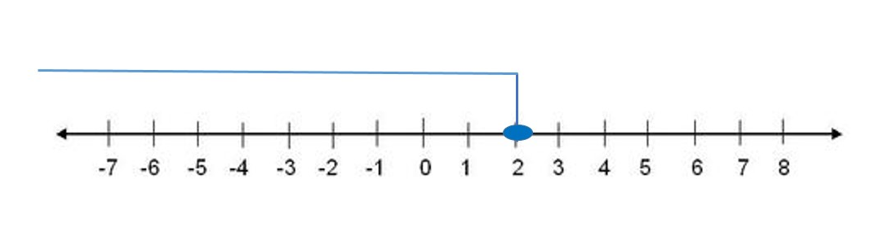

Solution:
$\left\{x | x ∈R, x≤2\right\}= \left(-∞,\left.2\right]\right.$

- Solve the following inequality and graph it:
$2\left(x-4\right)>x-3$

Applying distributive property:
$$2x-8>x-3 → 2x-x>-3+8$$
Solving for x:
$$x>5$$

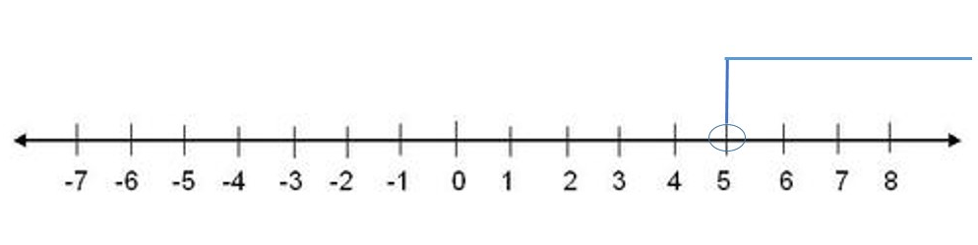

Solution:
$\left\{x | x ∈R, x>5\right\}= \left(5,∞\right)$

- Solve the following inequalities and graph its solution:

$\left\{\begin{aligned}3x+y≥0 \\ 2x+y≥0 \\ x≤2\end{aligned}\right.$

We have to graph each of the linear function that compound the system. One easy way to graph each linear function is to find its intercepts with the axes.

- $y=-3x$
$$x=0 →y=0 →(0,0)$$

$$y=6 →x=-2 →(-2,6)$$

- $y=-2x$

$$x=0 →y=0 →(0,0)$$

$$y=4 →x=-2 →(-2,4)$$
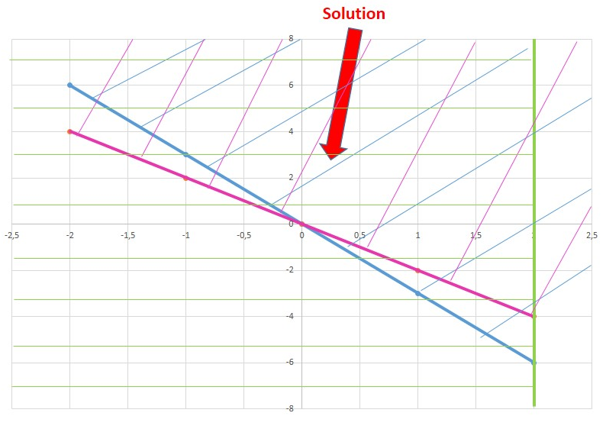

Proving with the point (1,2) that belongs to the solution region to verify if it satisfies the inequalities:

$$3(1)+2≥0 → 5>0$$

$$2\left(1\right)+2≥0 → 4>0$$

$$1<2$$

- Jessica works as an online tutor for $6 per hour. She also works as an editor for $3. She is allowed to work 30 hours per week and she wants to make at most $60. Write and graph a system of linear inequalities.

SOLUTION
Let´s define the variables that represent the system:

X= hours worked as online tutor
Y= Hours worked as editor

- As an online tutor she earns $6 per hour and as editor $3 to make at most $60, so the inequality is represented as follows:
$$6x+3y≤60 →simplifying →2x+y≤20$$

- She is allowed to works at most 30 hours, so:
$$x+y≤30$$

Finally we have the system:

$$\left\{\begin{aligned}y≤-2x+20 \\ y≤-x+30\end{aligned}\right.$$

We have to graph each of the linear function that compound the system. One easy way to graph each linear function is to find its intercepts with the axes.

- $y=-2x+20$
$$x=0 →y=20→(0, 20)$$

$$y=16 →x=2 →(2, 16)$$

- $y=-x+30$

$$x=0 →y=30 →(0, 30)$$

$$y=32 →x=-2 →(-2, 32)$$
Graphing:

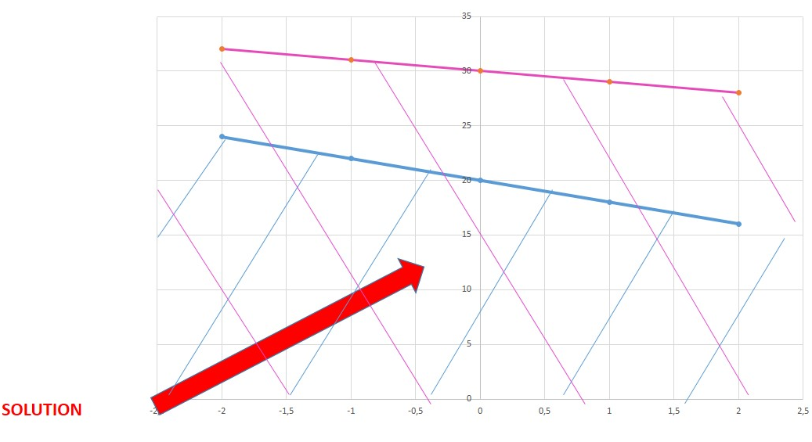
Proving with the point (1, 10) that belongs to the solution region to verify if it satisfies the inequalities:
$10≤-2\left(1\right)+20 → 10<18$

$10≤-1+30 → 10<29$

- A system of inequalities has:
a. one point as solution
b. a region of solutions
c. no solution
d. None of these

- Solve the following inequalities and graph its solution:

$\left\{\begin{aligned}y≥2x+1 \\ y≥-x+3\end{aligned}\right.$

We have to graph each of the linear function that compound the system. One easy way to graph each linear function is to find its intercepts with the axes.

- $y=2x+1$
$$x=0 →y=1→(0,1)$$

$$y=5 →x=2 →(2,5)$$

- $y=-x+3$

$$x=0 →y=3 →(0,3)$$

$$y=1 →x=2 →(2,1)$$
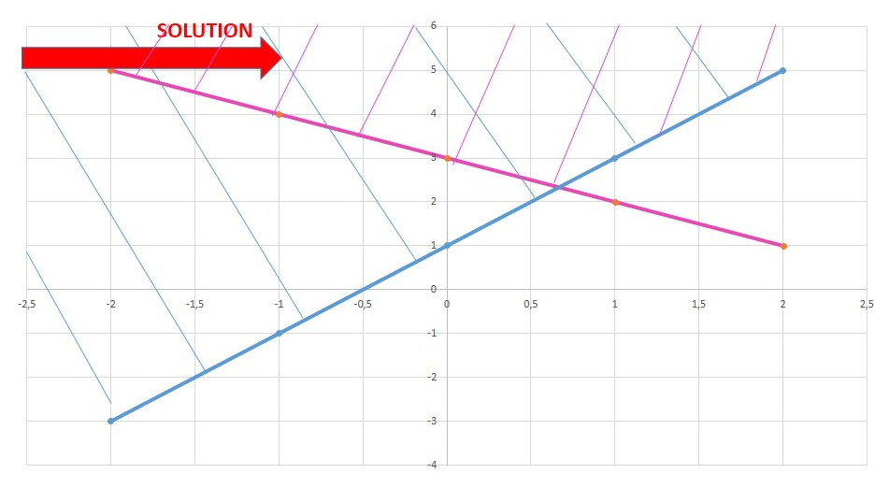
Proving with the point (1, 4) that belongs to the solution region to verify if it satisfies the inequalities:

$4≥2\left(1\right)+1 → 4>3$

$4≥-1+3 → 4>2$

