Identify from the graph the solution of the system and determine if it is an independent, inconsistent or dependent system

- 2.
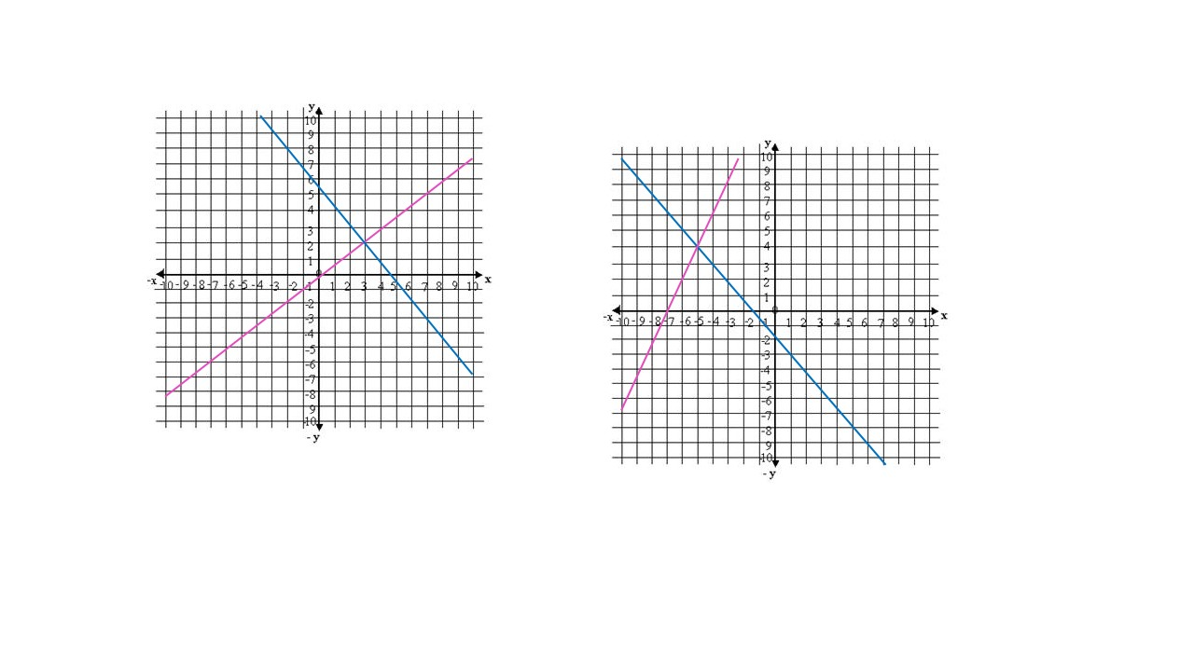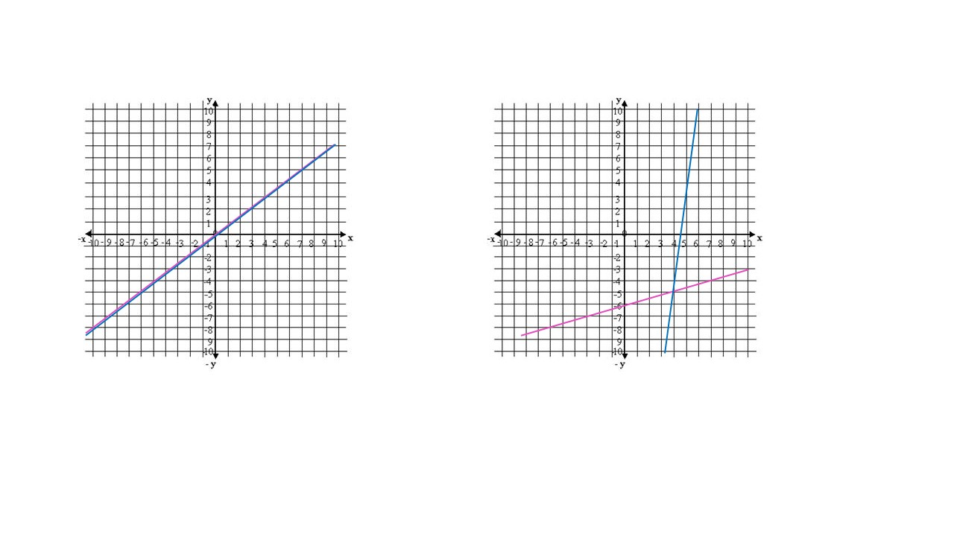

Find the solution of the following systems by graphing

3. $\left\{\begin{aligned}x+y=4 \\ x-y=2\end{aligned}\right.$ 4. $\left\{\begin{aligned}3x+5y=15 \\ 2x+2y=6\end{aligned}\right.$

Find the solution of the following systems by substitution and determine if it is an independent, inconsistent or dependent system

5. $\left\{\begin{aligned}x-y=10 \\ x+6y=1\end{aligned}\right.$ 6. $\left\{\begin{aligned}5\left(x+1\right)-2y=1 \\ y=2+x\end{aligned}\right.$

Find the solution of the following systems by elimination and determine if it is an independent, inconsistent or dependent system

7. $\left\{\begin{aligned}5x-y=4 \\ x-y=3\end{aligned}\right.$ 8. $\left\{\begin{aligned}x+y=4 \\ 5x-4y=6\end{aligned}\right.$

Solve the following verbal problems involving linear systems:

- A roll of 24 bills contains only $5 bills and $10 bills. If the value of the roll is $160, then how many of each bill are in the roll?

- A chemist needs to prepare a solution combining a 20% alcohol solution with a 60% alcohol solution to form 200 ml of a 45% final solution. How much of each solution should be used to form the mixture?

Express the following sets as intervals

- $\left\{x | x ∈R,4≤x≤8\right\}$

- $\left\{x | x ∈R,x>-2\right\}$

- $\left\{x | x ∈R, 2≤ x<9\right\}$

Solve the following inequalities and graph its solution

- $\frac{3x-4}{2}>5$

- $7x+2>16$

- $4\left(x+6\right)<2(x-1)$

Solve the following inequalities and graph its solution

- $\left\{\begin{aligned}3x+y≥0 \\ 2x+y≥0 \\ x≤2\end{aligned}\right.$

- $\left\{\begin{aligned}x+y≥2 \\ -4x+y<1\end{aligned}\right.$

Solve the following word problem:

- Jhon is preparing a party and he is buying the supplies at the Market. Regular sized boxes of spoons contain enough for 20 persons, while value-pack boxes contain enough for 30 persons. He needs at least enough spoons for the 60 guests who plan to attend. Write and graph a system of linear inequalities.

ANSWER

Identify from the graph the solution of the system and determine if it is an independent, inconsistent or dependent system

Remember the solution will be the point of intersection between both linear functions.
- Solution (-5,4) , Independent System
- Infinite solutions, Dependent System

Find the solution of the following systems by graphing

3. $\left\{\begin{aligned}x+y=4 \\ x-y=2\end{aligned}\right.$

One easy way to graph each linear function is to find its intercepts with the axes.

- $x+y=4$
$$x=0 →y=4 →(0,4)$$

$$y=0 →x=4 →(4,0)$$

- $x-y=2$
$$x=0 →y=-2→(0,-2)$$

$$y=0 → x=2 →(2,0)$$

System Solution (3, 1)

4. $\left\{\begin{aligned}3x+5y=15 \\ 2x+2y=6\end{aligned}\right.$

- $3x+5y=15$
$$x=0 →y=3 →(0,3)$$

$$y=0 →x=5 →(5,0)$$

- $2x+2y=6$

$$x=0 →y=3 →(0,3)$$

$$y=0 →x=3 →(3,0)$$

System Solution (0, 3)

Find the solution of the following systems by substitution and determine if it is an independent, inconsistent or dependent system

5. $\left\{\begin{aligned}x-y=10 \\ x+6y=1\end{aligned}\right.$

I. x - y = 10 and II. x + 6y = 1

We choose the equation which contains the easiest variable to solve. In this case we select to solve variable “x” from equation I and then substitute it in equation II to find the value of the other variable, like follows:

$$x=10+y$$

Substituting in II:
$$10+y+6y=1$$
$7y=-9 → y=-\frac{9}{7}$

Now, we calculate the value of variable “x” by substituting the result of “y” into the equation x = 10 + y
$$x=10-\frac{9}{7}=\frac{61}{7}$$
Solution (61/7, -9/7). Independent System

6. $\left\{\begin{aligned}5\left(x+1\right)-2y=1 \\ y=2+x\end{aligned}\right.$

I. 5(x+1) - 2y = 1 and II. y = 2 + x

We choose the equation which contains the easiest variable to solve. In this case we select to solve variable “y” from equation II and then substitute it in equation I to find the value of the other variable, like follows:

$$y=2+x$$
But first we have to order equation I:
$$5x+5-2y=1 → 5x-2y=-4$$
Substituting in I:
$$5x-2\left(2+x\right)=-4$$
Applying distributive property: $5x-2\left(2+x\right)=-4 → 3x=0 → x=\frac{0}{3}=0$

Now, we calculate the value of variable “y” by substituting the result of x into the equation y =2 + x
$$y=2+0=2$$
Solution (0, 2). Independent System

Find the solution of the following systems by elimination and determine if it is an independent, inconsistent or dependent system

7. $\left\{\begin{aligned}5x-y=4 \\ x-y=3\end{aligned}\right.$

I. 5x - y = 4 and II. x – y = 3

We interchange the “x” or “y” coefficients from equation I and equation II to eliminate one of the variables. In this case, we are going to interchange the “y” coefficients of both equations, like follows:

$$\left\{\begin{aligned}1(5x-y=4) \\ - 1(x-y=3)\end{aligned}\right.$$
As both coefficients have equal signs, we have to assign a negative sign to one of the coefficients so they can eliminate each other.
Applying distributive property: $$\left\{\begin{aligned}5x-y=4 \\ -x+y=-3\end{aligned}\right.$$
The result would be:
$$4x=1 →x=\frac{1}{4}$$

Now, we calculate the value of variable “y” by substituting the result of x into one of the equations:
$$y=x-3 → y=\frac{1}{4}-3=-\frac{11}{4}$$

Solution (1/4, -11/4). Independent System

8. $\left\{\begin{aligned}x+y=4 \\ 5x-4y=6\end{aligned}\right.$

I. x + y = 4 and II. 5x – 4y = 6

We interchange the “x” or “y” coefficients from equation I and equation II to eliminate one of the variables. In this case, we are going to interchange the “x” coefficients of both equations, like follows:

$$\left\{\begin{aligned}-5(x+y=4) \\ 1(5x-4y=6)\end{aligned}\right.$$
As both coefficients have equal signs, we have to assign a negative sign to one of the coefficients so they can eliminate each other
Applying distributive property: $$\left\{\begin{aligned}-5x-5y=-20 \\ 5x-4y=6\end{aligned}\right.$$
The result would be:
$$-9y=-14 →y=\frac{14}{9}$$

Now, we calculate the value of variable “x” by substituting the result of “y” into the equation x = 4 - y
$$x=4-\frac{14}{9}=\frac{22}{9}$$
Solution (22/9, 14/9). Independent System

Solve the following verbal problems involving linear systems:

- A roll of 24 bills contains only $5 bills and $10 bills. If the value of the roll is $160, then how many of each bill are in the roll?

- Identify variables
x: Number of $5 bills y: Number of $10 bills
- Set up equations

$$x+y=24 and 5x+10y=160$$
- Solve linear System
In this case we will use the elimination method, like follows:

$$\left\{\begin{aligned}x+y=24 \\ 5x+10y=160\end{aligned}\right.$$

We interchange the “x” or “y” coefficients from equation I and equation II to eliminate one of the variables. In this case, we are going to interchange the “x” coefficients of both equations, like follows:

$$\left\{\begin{aligned}5(x+y=24) \\ -1(5x+10y=160)\end{aligned}\right.$$
Applying distributive property: $$\left\{\begin{aligned}5x+5y=120 \\ -5x-10y=-160\end{aligned}\right.$$
The result would be:
$$-5y=-40 →y=8$$

Now, we calculate the value of variable “x” by substituting the result of “y” into one of the equations
$$x=24-y=24-8=16$$

There are 16 bills of $5 and 8 bills of $10

- A chemist needs to prepare a solution combining a 20% alcohol solution with a 60% alcohol solution to form 200 ml of a 45% final solution. How much of each solution should be used to form the mixture?

- Identify variables
x: Alcohol solution at 20% y: Alcohol solution at 60%
- Set up equations

$$x+y=200 and 0.20x+0.60y=0.45(200)$$
- Solve linear System
We will use the elimination method, like follows:

$$\left\{\begin{aligned}x+y=200 \\ 0.20x+0.60y=90\end{aligned}\right.$$

We interchange the “x” or “y” coefficients from equation I and equation II to eliminate one of the variables. In this case, we are going to interchange the “x” coefficients of both equations, like follows:

$$\left\{\begin{aligned}0.20(x+y=200) \\ -1 (0.20x+0.60y=90)\end{aligned}\right.$$
Applying distributive property: $$\left\{\begin{aligned}0.20x+0.20y=40 \\ -0.20x-0.60y=-90\end{aligned}\right.$$
The result would be:
$$-0.40y=-50 →y=125 ml$$

Now, we calculate the value of variable “x” by substituting the result of “y” into one of the equations
$$x=200-y=200-125=75 ml$$

It should be used 75 ml of solution at 20% and 125 ml of solution at 60%

Express the following sets as intervals
Remember that:
$$\left\{x | x ∈R, x<a\right\}= \left(-∞, a\right)$$
$$\left\{x | x ∈R, x>a\right\}= \left(a, ∞\right)$$
$$\left\{x | x ∈R, x≤a\right\}= \left(-∞,\right.\left.a\right]$$
$$\left\{x | x ∈R, x≥a\right\}= \left[a,\left.∞\right)\right.$$
$$\left\{x | x ∈R, a≤ x≤b\right\}=\left[a,\left.b\right]\right.$$
$$\left\{x | x ∈R, a< x≤b\right\}=\left(a,\left.b\right]\right.$$
$$\left\{x | x ∈R, a≤ x<b\right\}=\left[a,\left.b\right)\right.$$
$$\left\{x | x ∈R, a< x<b\right\}=\left(a,\left.b\right)\right.$$

11. $\left\{x | x ∈R, 4≤ x≤8\right\}=\left[4,\left.8\right]\right.$

$$12. \left\{x | x ∈R,x>-2 \right\}=\left(-2,∞\right)$$

- $\left\{x | x ∈R, 2≤ x<9\right\}=\left[2,\left.9\right)\right.$

Solve the following inequalities and graph its solution

- $\frac{3x-4}{2}>5$

$$2×\left(\frac{3x-4}{2}\right)>2×5 → 3x-4>10 → 3x>14$$
Solving for x:
$$\frac{1}{3}\left(3x\right)>\frac{1}{3}\left(14\right) → x>\frac{14}{3}$$

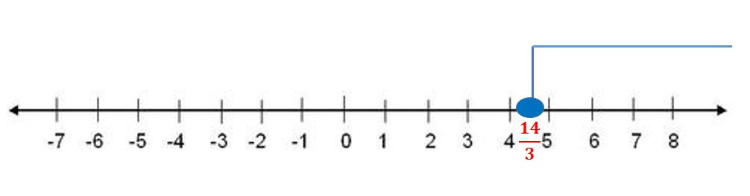

Solution:
$$\left\{x | x ∈R, x>\frac{14}{3}\right\}= \left(\frac{14}{3}, ∞\right)$$

- $7x+2>16$

$$7x+2>16 → 7x >14 →\frac{1}{7}\left(7x\right)>\frac{1}{7}\left(16\right) → x>\frac{16}{7}$$

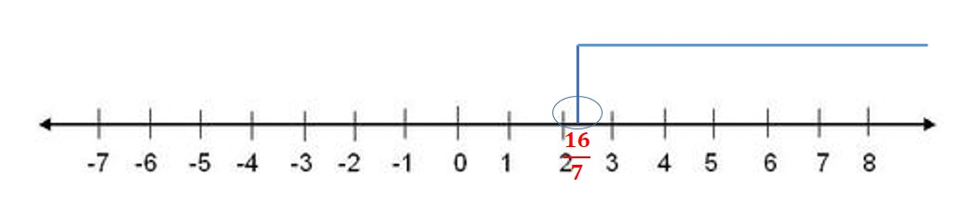

Solution: $$\left\{x | x ∈R, x>\frac{16}{7}\right\}= \left(\frac{16}{7}, ∞\right)$$

- $4\left(x+6\right)<2(x-1)$

Applying distributive property:

$$4x+24<2x-2 → 2x<-26 → \frac{1}{2}( 2x)<\frac{1}{2}(-26 )$$
Solving for x:
$$x<-13$$

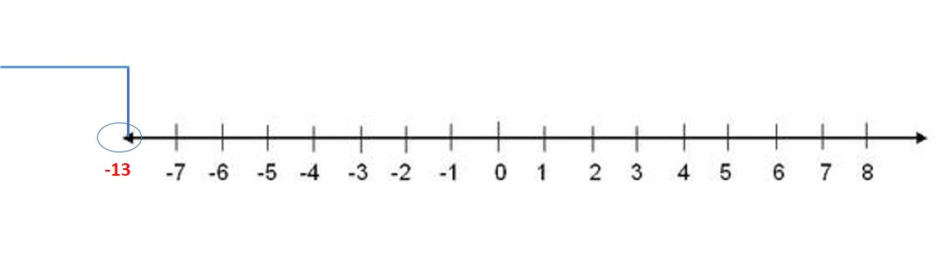

Solution:
$$\left\{x | x ∈R, x<-13\right\}= \left(- ∞,-13\right)$$

Solve the following inequalities and graph its solution

- $\left\{\begin{aligned}3x+y≥0 \\ 2x+y≥0 \\ x≤2\end{aligned}\right.$

We have to graph each of the linear function that compound the system. One easy way to graph each linear function is to find its intercepts with the axes.

- $y=-3x$
$$x=0 →y=0 →(0,0)$$

$$y=6 →x=-2 →(-2,6)$$

- $y=-2x$

$$x=0 →y=0 →(0,0)$$

$$y=4 →x=-2 →(-2,4)$$
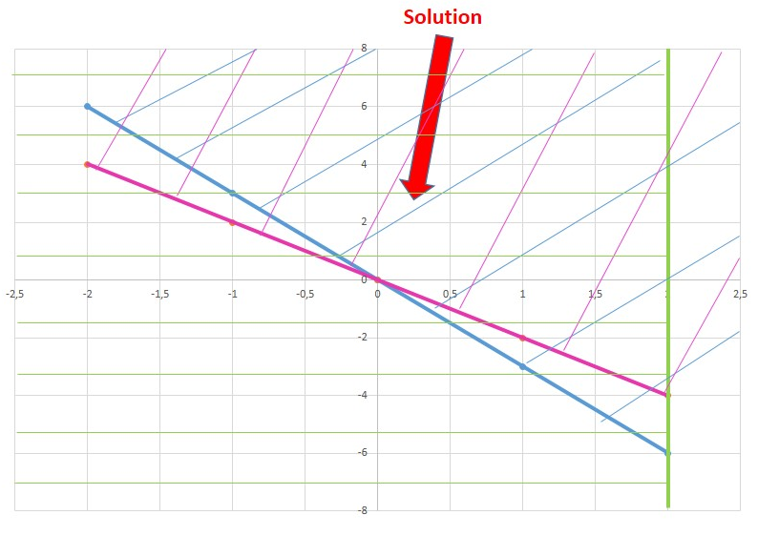

Proving with the point (1,2) that belongs to the solution region to verify if it satisfies the inequalities:

$$3(1)+2≥0 → 5>0$$

$$2\left(1\right)+2≥0 → 4>0$$

$$1<2$$

- $\left\{\begin{aligned}x+y≥2 \\ -4x+y<1\end{aligned}\right.$

We have to graph each of the linear function that compound the system. One easy way to graph each linear function is to find its intercepts with the axes.

- $y=-x+2$
$$x=0 →y=2→(0,2)$$

$$y=0 →x=2 →(2,0)$$

- $y=4x+1$

$$x=0 →y=1 →(0,1)$$

$$y=0 →x=-1/4 →(-1/4,0)$$

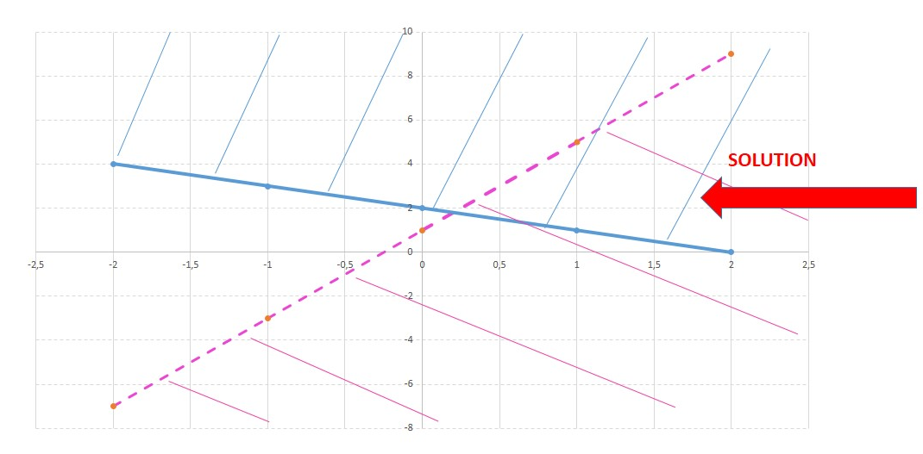
The segmented line is because the border of the line does not belong to the solution and the straight line is because the border of the line belongs to the solution.
Proving with the point (1,2) that belongs to the solution region to verify if it satisfies the inequalities:

$$x+y≥2 → 1+2≥2 → 3≥2$$

$$-4x+y<1 →-4\left(1\right)+2<1 → -2<1$$

Solve the following word problem:

- Jhon is preparing a party and he is buying the supplies at the Market. Regular sized boxes of spoons contain enough for 20 persons, while value-pack boxes contain enough for 30 persons. He needs at least enough spoons for the 60 guests who plan to attend. Write and graph a system of linear inequalities.

SOLUTION
Let´s define the variables that represent the system:
X= Number of regular boxes of spoons.
Y= Number of value-packs boxes of spoons.

- The statement says 40 regular size spoons and 20 value-pack spoons for at least 60 guests , so we have:
$$40x+20y≥60 →simplifying→2x+y≥3$$

- As we know the amount of spoons can never be negative, so:

$$x≥0 and y≥0$$

We have to graph each of the linear function that compound the system. One easy way to graph each linear function is to find its intercepts with the axes.

- $y=-2x+3$
$$x=0 →y=3→(0, 3)$$

$$y=0→x=\frac{3}{2} →(3/2, 0)$$
Graphing:

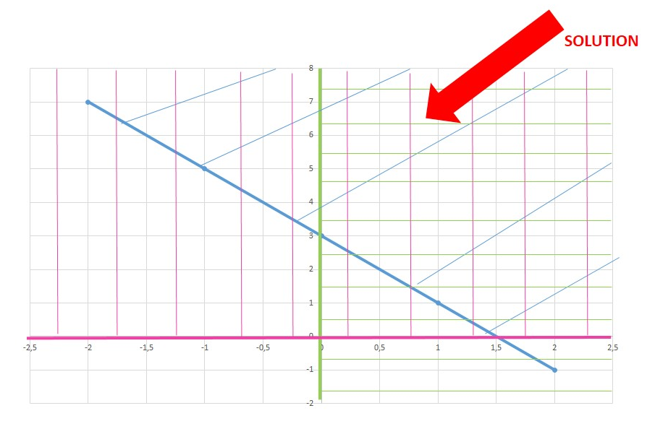

Proving with the point (2, 2) that belongs to the solution region to verify if it satisfies the inequalities:

$$2x+y≥3→-2\left(2\right)+2≥3 → 6≥3$$

$$y≥0 → 2≥0 and x≥0 → 2≥0$$

