- Identify the vertex of the graph. Also, tell whether the vertex is a minimum or a maximum.
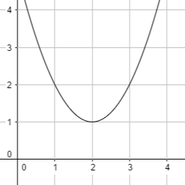
- Graph the quadratic function $y= -1.5x^{2}$.


- Identify the domain and range of the function $y=x^{2}-3$.

- The line that divides the parabola into parts that are mirror images of each other is known as an:
  - Axis of symmetry
  - Vertex
  - Minimum
  - Maximum
- Identify the axis of symmetry and vertex of the graph of the quadratic function $f(x)=x^{2}-8x$.

- Graph the function using the vertex and axis of symmetry.
$$f\left(x\right)=x^{2}+4x-2$$

- The point where the graph of the quadratic function intersects with axis of symmetry is known as:
  - Center
  - Vertex
  - Minimum
  - Maximum

- Find the solution of the equation $x^{2}+2=0$ by graphing the related function or mention if the equation has no solution.
- Find the solution of the equation ${4b}^{2}-36=0$ by finding the square roots or mention if the equation has no solution.

- If the graph of the quadratic function does not intersect the x-axis, the equation has:

  - 1 solution
  - 0 solution
  - 2 solutions
  - None of these

- Solve the equation $y\left(3y+12\right)=0$

- Solve the equation $x^{2}+11x+28=0$ by factoring.

- The solution of $x^{2}-9x-36=0$ is:

  - $x=4,-9$
  - $x=4,9$
  - $x=3,-9$
  - $x=-12,3$

- Find the value of $c$ which will make the expression a perfect-square trinomial.
$x^{2}+18x+c$

- Solve the equation by completing the square.
$z^{2}-18z=63$

- To complete the square in $x^{2}-\frac{1}{2}x$ we will add:

  - $\frac{1}{4}$
  - $\frac{1}{16}$
  - $\frac{1}{8}$
  - $8$

- Evaluate the discriminant of the equation and tell how many solutions the equation has and are the solutions real or imaginary.
$y=4x^{2}-4x+1$

- The quadratic equation has real solutions if:

  - $b^{2}-4ac<0$
  - $b^{2}-4ac=0$
  - $b^{2}-4ac>0$
  - None of these
- Solve the quadratic equation using the quadratic formula.
$x^{2}+9x-13=0$

- Graph the set of points and determine which model best represents the data set.
(-1,-1), (-2,-2), (-3,-3), (-4,-4)

- The graph of the equation $y=e^{x}$ is a/an:

  - Straight line
  - U-shaped curve
  - Increasing curve
  - None of these

x | y
-2 | 12
-1 | 6
0 | 3
1 | 1.5
2 | 0.75
- Which model best describes the data in each table given below?

- Solve the system of equations by graphing.
$y=x^{2}+x-3 ; y=x+1$

- Solve the system of equation algebraically.
$y= x^{2}-3x-27$ ; $y=x-6$

- If the graphs of linear and quadratic function do not intersect each other, then the system of equation has:

  - 2 solutions
  - 1 solution
  - 0 solutions
  - None of these

ANSWERS:
- Identify the vertex of the graph. Also tell whether the vertex is a minimum or a maximum.
Vertex = (2,1)
Parabola opens up, vertex is a minimum.
- Graph the quadratic function $y= -1.5x^{2}$.
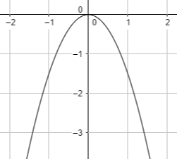
- Identify the domain and range of the function $y=x^{2}-3$.
Domain: set of all real numbers
Range: $y ≥-3$

- The line that divides the parabola into parts that are mirror images of each other is known as an:
  - Axis of symmetry
  - Vertex
  - Minimum
  - Maximum
- Identify the axis of symmetry and vertex of the graph of the quadratic function $f(x)=x^{2}-8x$.
Axis of symmetry:
$x=-\frac{b}{2a} →-\frac{-8}{2\left(1\right)}=4$
Vertex:
$f\left(4\right)=4^{2}-8\left(4\right)=16-32= -16=(4,-16)$
- Graph the function using the vertex and axis of symmetry.
$$f\left(x\right)=x^{2}+4x-2$$Axis of symmetry:
$x=-\frac{b}{2a} →-\frac{4}{2\left(1\right)}=-2$
Vertex:
$f\left(-2\right)=(-{2)}^{2}+4(-2)-2=-6=(-2,-6)$
Graph:
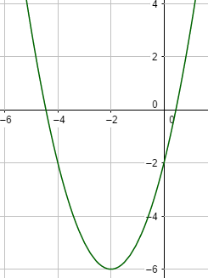
- The point where the graph of the quadratic function intersects with axis of symmetry is known as:
  - Center
  - Vertex
  - Minimum
  - Maximum

- Find the solution of the equation $x^{2}+2=0$ by graphing the related function or mention if the equation has no solution.
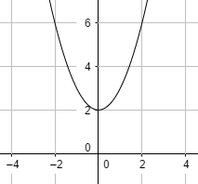
Solutions: $No solution$
- Find the solution of the equation ${4b}^{2}-36=0$ by finding the square roots or mention if the equation has no solution.
$b^{2}=\frac{36}{4}=9$
$\sqrt{b^{2}}=\sqrt{9}$
$b= ±3$
- If the graph of the quadratic function does not intersect the x-axis, the equation has:

  - 1 solution
  - 0 solution
  - 2 solutions
  - None of these

- Solve the equation $y\left(3y+12\right)=0$
By zero-product property:
$y=0$ or $3y+12=0$
$y=0$ ; $3y=-12$
$y=0$ ; $y=-4$
- Solve the equation $x^{2}+11x+28=0$ by factoring.
Factorize:
$x^{2}+7x+4x+28=0$
$x\left(x+7\right)+4\left(x+7\right)=0$
$\left(x+4\right)\left(x+7\right)=0$
$x=-4$ ; $x=-7$
- The solution of $x^{2}-9x-36=0$ is:

  - $x=4,-9$
  - $x=4,9$
  - $x=3,-9$
  - $x=-12,3$
- Find the value of $c$ which will make the expression a perfect-square trinomial.
$x^{2}+18x+c$
Here the coefficient of linear term is $18$.
$c= {\left(\frac{18}{2}\right)}^{2}=9^{2}=81$
So, the trinomial is $x^{2}+18x+81$

- Solve the equation by completing the square.
$z^{2}-18z=63$
Here the term to add is ${\left(\frac{-18}{2}\right)}^{2}={(-9)}^{2}=81$
$z^{2}-18z+81=63+81$
${(z-9)}^{2}=144$
$z-9=±12$
$z-9=12$ ; $z-9=-12$
$z=21$ ; $z=-3$

- To complete the square in $x^{2}-\frac{1}{2}x$ we will add:

  - $\frac{1}{4}$
  - $\frac{1}{16}$
  - $\frac{1}{8}$
  - $8$
- Evaluate the discriminant of the equation and tell how many solutions the equation has and are the solutions real or imaginary.
$y=4x^{2}-4x+1$
discriminant: $b^{2}-4ac={(-4)}^{2}-4\left(4\right)\left(1\right)=16-16=0$
Number of solutions: 1 since discriminant = 0
Real or Imaginary: Real
- The quadratic equation has real solutions if:

  - $b^{2}-4ac<0$
  - $b^{2}-4ac=0$
  - $b^{2}-4ac>0$
  - None of these
- Solve the quadratic equation using the quadratic formula.
$x^{2}+9x-13=0$
Here $a=1, b= 9, c=-13$
$x= \frac{-(9)±\sqrt{{(9)}^{2}-4\left(1\right)\left(-13\right)} }{2\left(1\right)}$
$x= \frac{-9±\sqrt{81+52} }{2\left(1\right)}$
$x= \frac{-9±\sqrt{133} }{2}$
$x= \frac{-9+\sqrt{133} }{2}$ ; $x= \frac{-9-\sqrt{133} }{2}$
- Graph the set of points and determine which model best represents the data set.
(-1,-1), (-2,-2), (-3,-3), (-4,-4)
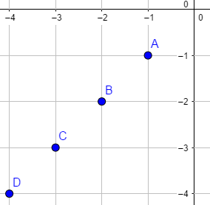
The graph represents a linear model
since the points make a straight line.
- The graph of the equation $y=e^{x}$ is a/an:

  - Straight line
  - U-shaped curve
  - Increasing curve
  - None of these

x | y
-2 | 12
-1 | 6
0 | 3
1 | 1.5
2 | 0.75
- Which model best describes the data in each table given below?

The ratio of consecutive y-values is: $\frac{12}{6}= \frac{6}{3}=2$
So the table represents an exponential model

- Solve the system of equations by graphing.
$y=x^{2}+x-3 ; y=x+1$
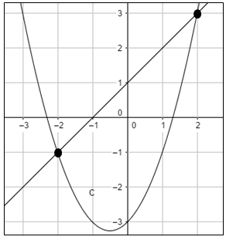
The points where two graphs intersect are (-2,-1) and (2,3).

- Solve the system of equation algebraically.
$y= x^{2}-3x-27$ ; $y=x-6$
First put the value of y from linear equation into the quadratic equation.
$x-6=x^{2}-3x-27$ $→ x^{2}-3x-27-x+6=0$
$→ x^{2}-4x-21=0$
$→ x^{2}-7x+3x-21=0$
$→(x-7)(x+3)=0$
$→x=7 , x= -3$
$y=7-6=1$ ; $y= -3-6=-9$
Solutions: $\left(7,1\right) , (-3,-9)$
- If the graphs of linear and quadratic function do not intersect each other, then the system of equation has:

  - 2 solutions
  - 1 solution
  - 0 solutions
  - None of these

