- Identify the vertex of the graph. Also, tell whether the vertex is a minimum or a maximum.
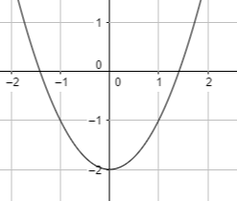

- Graph the quadratic function $y=x^{2}-1$.

- Identify the domain and range of the function $y={10x}^{2}+0.5$.

- Identify the axis of symmetry and vertex of the graph of the quadratic function $f\left(x\right)=x^{2}-8$.

- Graph the function using the vertex and axis of symmetry.
$$f\left(x\right)=-\frac{1}{2}x^{2}+8x-2$$

- Find the solution of the equation $x^{2}-15=-15$ by graphing the related function or mention if the equation has no solution.

- Find the solution of the equation ${2g}^{2}-16=-16$ by finding the square roots or mention if the equation has no solution.

- Solve the equation $(8t+4)\left(3t+6\right)=0$

- Solve the equation $s^{2}+9s=-20$ by factoring.

- Find the value of $c$ which will make the expression a perfect-square trinomial.
$p^{2}-10p+c$

- Solve the equation by completing the square.
$x^{2}+8x-9=0$

- Evaluate the discriminant of the equation and tell how many solutions the equation has and are the solutions real or imaginary.
$y={-5x}^{2}+6x-4$

- Solve the quadratic equation using the quadratic formula.
$x^{2}=3x+2$

- Graph the set of points and determine which model best represents the data set.
(0,3), (1,1), (2,0), (3,1)
- The graph of the equation $y=e^{x}$ is a/an:

  - Straight line
  - U-shaped curve
  - Increasing curve
  - None of these

ANSWERS:
      - Identify the vertex of the graph. Also, tell whether the vertex is a minimum or a maximum.
Vertex = (0,-2)
Parabola opens up, vertex is a minimum.
      - Graph the quadratic function $y=x^{2}-1$.
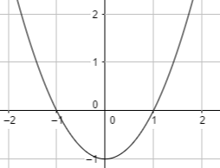
      - Identify the domain and range of the function $y={10x}^{2}+0.5$.
Domain: set of all real numbers
Range: $y ≥0.5$

      - Identify the axis of symmetry and vertex of the graph of the quadratic function $f\left(x\right)=x^{2}-8$.
Axis of symmetry:
$x=-\frac{b}{2a} →-\frac{0}{2\left(1\right)}=0$
Vertex:
$f\left(0\right)=0^{2}-8=-8=(0,-8)$

      - Graph the function using the vertex and axis of symmetry.
$$f\left(x\right)=-\frac{1}{2}x^{2}+8x-2$$Axis of symmetry:
$x=-\frac{b}{2a} →-\frac{8}{2\left(-\frac{1}{2}\right)}=8$
Vertex:
$f\left(8\right)=-\frac{1}{2}{\left(8\right)}^{2}+8(8)-2=30=(8,30)$
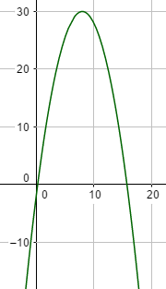

      - Find the solution of the equation $x^{2}-15=-15$ by graphing the related function or mention if the equation has no solution.
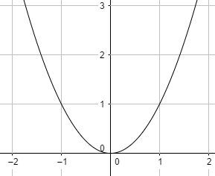
Solutions: $x= 0$
      - Find the solution of the equation ${2g}^{2}-16=-16$ by finding the square roots or mention if the equation has no solution.
${2g}^{2}=16-16=0$
$g^{2}=0$
$\sqrt{g^{2}}=\sqrt{0}$
$g= 0$
      - Solve the equation $(8t+4)\left(3t+6\right)=0$
By zero-product property:
$8t+4=0$ or $3t+6=0$
$8t=-4$ ; $3t=-6$
$t=-\frac{1}{2}$ ; $t=-2$

      - Solve the equation $s^{2}+9s=-20$ by factoring.
Factorize:
$s^{2}+9s+20=0$
$s^{2}+4s+5s+20=0$
$s\left(s+4\right)+5\left(s+4\right)=0$
$\left(s+4\right)\left(s+5\right)=0$
$s=-4$ ; $s=-5$
      - Find the value of $c$ which will make the expression a perfect-square trinomial.
$p^{2}-10p+c$
Here the coefficient of linear term is $-10$.
$c= {\left(\frac{-10}{2}\right)}^{2}={(-5)}^{2}=25$
So, the trinomial is $p^{2}-10p+25.$

      - Solve the equation by completing the square.
$x^{2}+8x-9=0$
Here the term to add is ${\left(\frac{8}{2}\right)}^{2}={(4)}^{2}=16$
$x^{2}+8x+16=9+16$
${(x+4)}^{2}=25$
$x+4=±5$
$x+4=5$ ; $x+4=-5$
$x=1$ ; $x=-9$

      - Evaluate the discriminant of the equation and tell how many solutions the equation has and are the solutions real or imaginary.
$y={-5x}^{2}+6x-4$
discriminant: $b^{2}-4ac={\left(6\right)}^{2}-4\left(-5\right)\left(-4\right)=36-80=-44$
Number of solutions: 2 since discriminant < 0
Real or Imaginary: Imaginary
      - Solve the quadratic equation using the quadratic formula.
$x^{2}=3x+2$
$x^{2}-3x-2=0$
Here $a=1, b= -3, c=-2$
$x= \frac{-(-3)±\sqrt{{(-3)}^{2}-4\left(1\right)\left(-2\right)} }{2\left(1\right)}$
$x= \frac{+3±\sqrt{9+8} }{2\left(1\right)}$
$x= \frac{+3±\sqrt{17} }{2}$ $x= \frac{+3+\sqrt{17} }{2}$ ; $x= \frac{+3-\sqrt{17} }{2}$
      - Graph the set of points and determine which model best represents the data set.
(0,3), (1,1), (2,0), (3,1)
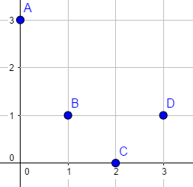
The graph represents a quadratic model
since the points make a U shaped curve.
      - The graph of the equation $y=e^{x}$ is a/an:

  - Straight line
  - U-shaped curve
  - Increasing curve
  - None of these

