**Change Expressed as a Percent**

**Directions: Solve each problem. Use your answer to navigate through the maze. Show your work.**

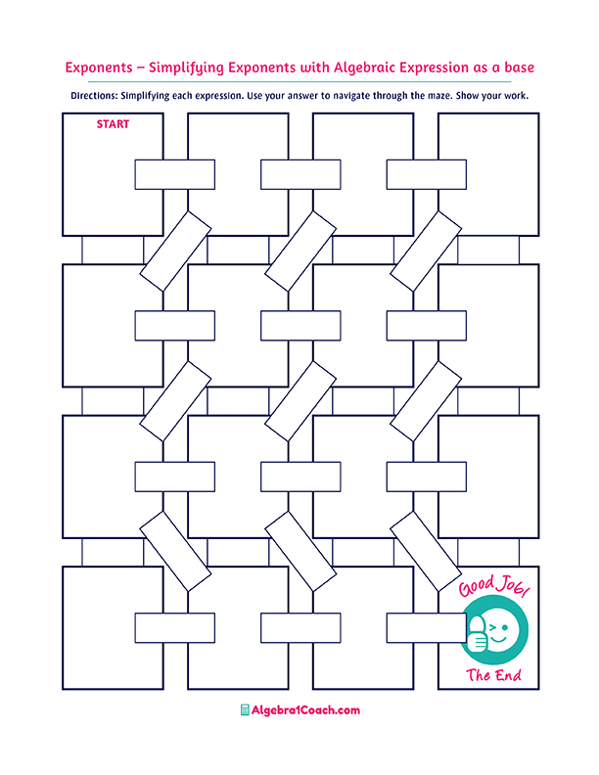

**Percent increase**

$$48$$

$$33\%$$

$$17\%$$

$$25.55\%$$

**Positive**

**Original: 45**

**New Amount: 60**

**The percent change:**

**What percent**

**of 45 is 11.5?**

**The percent error is always:**

**Percent Error**

$$2.5\%$$

$$0.12\% of 400$$

$$2.2\%$$

$$12.3$$

$$-0.875$$

$$-0.17$$

$$55\%$$

**If the percent change is negative, there is a:**

**If the percent change is positive,**

**there is a:**

**Percent Decrease**

**Original: 40**

**New Amount: 75**

**The percent change:**

**Percent Decrease**

**Percent Change**

$25\%$

**:**

**Percent Increase**

**Percent Decrease**

**Percent Change**

$-65\%$

**Original: $35**

**New Price: $29**

**The percent change:**

**Original: 26**

**New Amount: 18**

**The percent change:**

$$-0.33$$

$$-31\%$$

$$0.31$$

$$87.5\%$$

**Percent**

**increase**

**Percent decrease**

$$0.48$$

**What percent**

**of 500 is 11?**

$$14\% of 230$$

$$0.2\% of 200$$

$$3.3$$

$$33\% of 10$$

$$35.1$$

$$32.2$$

$$-87.5\%$$

$$1.5\%$$

$$-17\%$$

$$0.4$$

$$0.22\%$$

$$22\%$$