Change Expressed as a Percent
Directions: Solve each problem. Use your answer to navigate through the maze. Show your work.
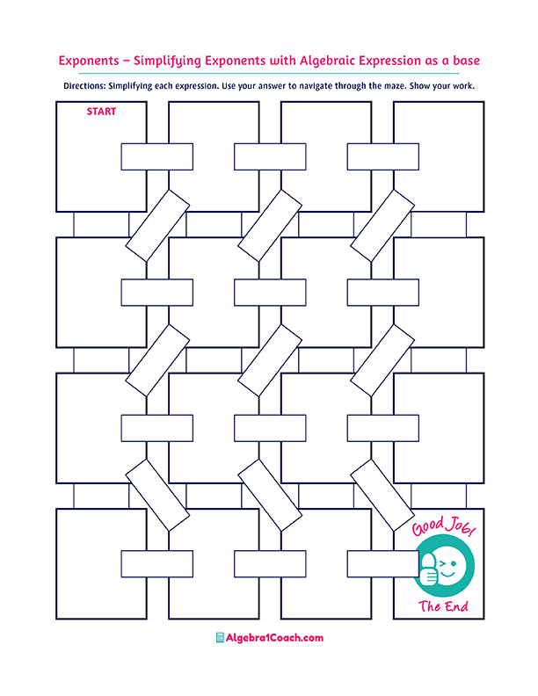
Percent increase

$$48$$
$$33\%$$
$$17\%$$
$$25.55\%$$

Positive
Original: 45
New Amount: 60
The percent change:
What percent
of 45 is 11.5?

The percent error is always:
Percent Error
$$2.5\%$$

$$0.12\% of 400$$

$$2.2\%$$

$$12.3$$

$$-0.875$$

$$-0.17$$

$$55\%$$

If the percent change is negative, there is a:
If the percent change is positive,
there is a:
Percent Decrease

Original: 40
New Amount: 75
The percent change:
Percent Decrease
Percent Change
$25\%$
:
Percent Increase
Percent Decrease
Percent Change
$-65\%$
Original: $35
New Price: $29
The percent change:

Original: 26
New Amount: 18
The percent change:
$$-0.33$$

$$-31\%$$

$$0.31$$

$$87.5\%$$
Percent
increase
Percent decrease

$$0.48$$

What percent
of 500 is 11?

$$14\% of 230$$

$$0.2\% of 200$$

$$3.3$$

$$33\% of 10$$

$$35.1$$

$$32.2$$

$$-87.5\%$$
$$1.5\%$$

$$-17\%$$

$$0.4$$
$$0.22\%$$
$$22\%$$

