**Literal Equations and Formulas**

**Directions: Solve each equation for the variable given. Use your answer to navigate through the maze. Show your work.**

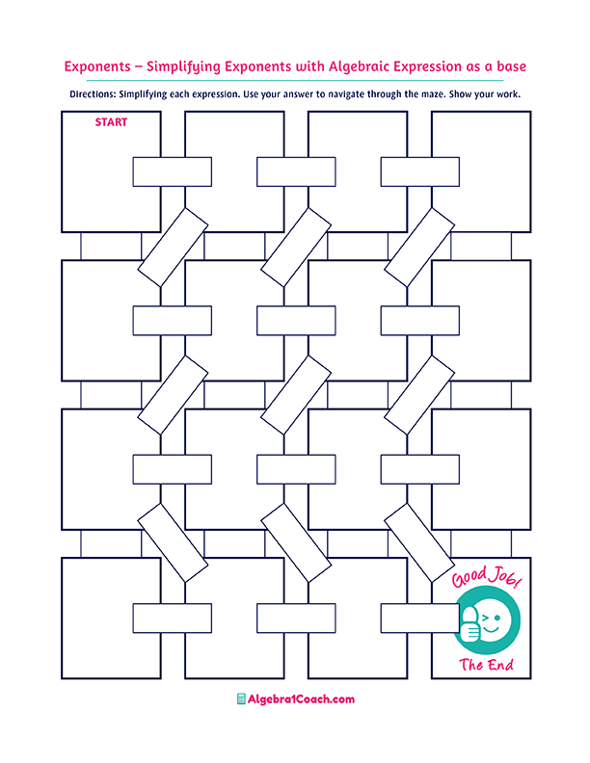

$$x=-5y+18$$

$$x=\frac{4}{-2+3y}$$

$$x=\frac{-1}{2}$$

$$\frac{x}{2}-y=2y;$$

$$y=3$$

$$x=-2$$

$$-4y=-2x+8;$$

$$y=1$$

$$4a=2c-3; a$$

$$\frac{12+x}{4}=\frac{y-x}{2};x$$

$$x=\frac{1}{2}$$

$$x=\frac{2y-12}{6}$$

$$z=\frac{2xy-8}{y}$$

$$x=5y+18$$

$$2y+\frac{10}{x}=y$$

$$y=5$$

$$x=2$$

$$2x-2=3y+5;$$

$$y=-1$$

$$x=4y+18$$

$$x=-\frac{1}{3}$$

$$x+xy=1-y;$$

$$y=2$$

$$x=\frac{2y-12}{3}$$

$$x=2y-6$$

$$x=\frac{4y-10}{3}$$

$$x=3y-18$$

$$x=5y-18$$

$$x=\frac{3y-10}{4}$$

$$x=\frac{4y-3}{10}$$

$$\frac{x-5}{y+2}=4;x$$

$$x=\frac{6y+5}{6}$$

$$\frac{6x-5}{2}=3y; x$$

$$x=\frac{6y+5}{6}$$

$$x=\frac{-2+3y}{4}$$

$$x=\frac{2}{4-3y}$$

$$a=\frac{4c-3}{2}$$

$$a=\frac{2c-4}{3}$$

$$a=\frac{2c-3}{4}$$

$$z=\frac{xy-8}{2y}$$

$2xy-yz=8$**; $z$**

$$\frac{y}{2}=-2x+y;$$

$$y=-2$$

$$\frac{2x+4}{2}=2y; x$$

$$y-\frac{x}{4}=\frac{x+5}{2};x$$

$$x=-3$$

$$-2x+3yx=4; x$$

$$x=4y+13$$

$$\frac{x+2}{y+4}=5;x$$

$$x=3$$

$$x=-2$$

$$x=1$$

$$x=6$$

$$x=2$$