**Ratios, Rates, and Conversions**

**Directions: Solve each problem. Use your answer to navigate through the maze. Show your work.**

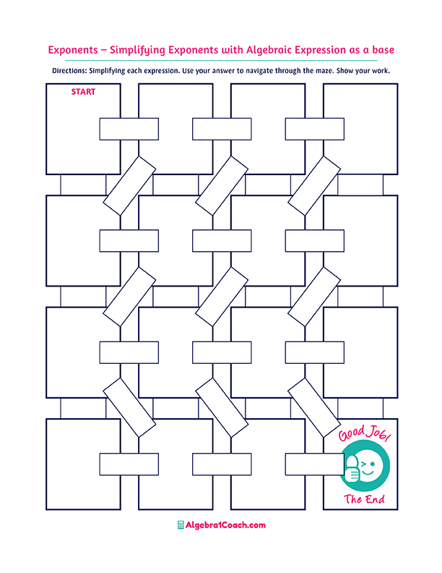

**168**

**1 ton**

**= 2,000 pounds**

**36 miles/hour**

**90 minutes**

**2 : 3**

**12 inches**

**=1 foot**

**Find the unit rate.**

**5 pounds cost $10**

**10 pounds cost $5**

**A rate having 1**

**as a denominator**

**is known as:**

**Convert 1.5 hours**

**in minutes.**

**Find the unit rate.**

**216 miles in 6 hours**

**Convert 10 minutes**

**in seconds.**

**The ratio 11 : 33 simplified is:**

**In 7 days, the**

**number of hours is:**

**6 quarts =**

**1 gallon**

**Convert 12 feet to yard.**

**$2/pounds**

**$ 0.5/pounds**

**$ 0.5/pounds**

**$0.2/pounds**

**Find the unit rate.**

**10 pounds cost $5**

**1 : 3**

**Choose the correct conversion factor.**

**Unit Rate**

**Average Rate**

**2 mile=6,280 feet**

**Choose the correct conversion factor.**

**3,600 seconds**

**2 : 8**

**3 : 2**

**The ratio 16 : 24 simplified is:**

**600 minutes**

**52.8 quarts**

**0.528 quarts**

**33 yards**

**3.3 yards**

**Convert 10 feet to yards.**

**5.28 quarts**

**Convert 5 liters to quarts.**

**600 seconds**

**0.33 yards**

**120 minutes**

**Unit Price**

**84**

**2 feet = 1 yard**

**144**

**1 : 11**

**Convert 1 mile to feet**

**4 yards**