Ratios, Rates, and Conversions
Directions: Solve each problem. Use your answer to navigate through the maze. Show your work.
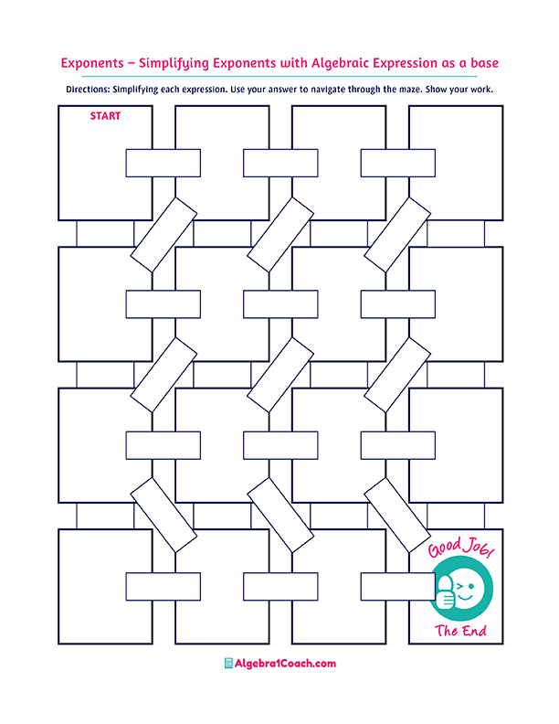
90 minutes
1 ton
= 2,000 pounds
120 minutes
36 miles/hour
2 : 3
12 inches
=1 foot
Find the unit rate.
5 pounds cost $10

10 pounds cost $5
A rate having 1
as a denominator
is known as:
Convert 1.5 hours
in minutes.
Find the unit rate.
216 miles in 6 hours
Convert 10 minutes
in seconds.

The ratio 11 : 33 simplified is:
In 7 days, the
number of hours is:
6 quarts =
1 gallon

Convert 12 feet to yard.
$2/pounds
$ 0.5/pounds
$ 0.5/pounds
$0.2/pounds
Find the unit rate.
10 pounds cost $5
1 : 3
Choose the correct conversion factor.

Unit Rate
Average Rate
2 mile=6,280 feet
Choose the correct conversion factor.
3,600 seconds
2 : 8
3 : 2
The ratio 16 : 24 simplified is:
600 minutes
52.8 quarts
0.528 quarts
33 yards
3.3 yards
Convert 10 feet to yards.
5.28 quarts
Convert 5 liters to quarts.
600 seconds
0.33 yards
Unit Price
84
2 feet = 1 yard
144
1 : 11
168
Convert 1 mile to feet
4 yards

