**Proportions and Similar Figures**

**Directions: Answer each question. Use your answer to navigate through the maze. Show your work.**

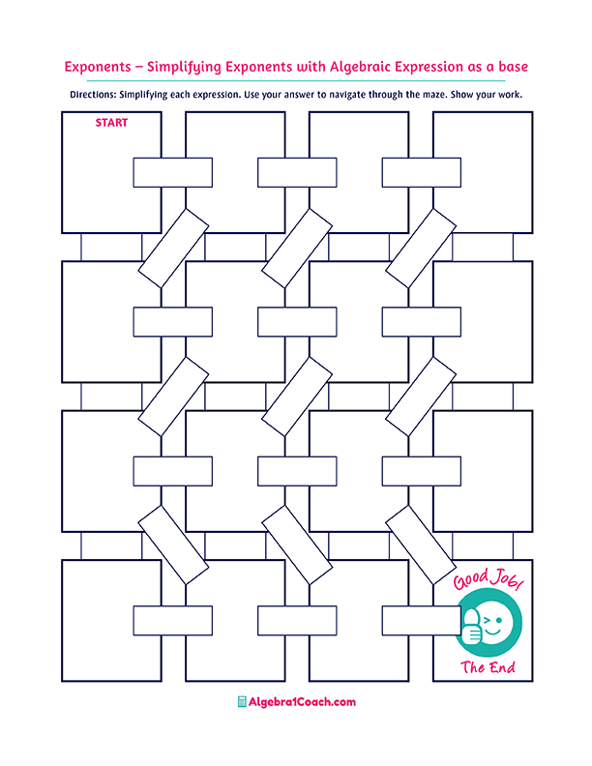

**A proportion is**

**an equation having two ratios ________.**

$$c=3$$

**The similar**

**figures have:**

**Equal**

**The corresponding angles of the similar figures are:**

**Same shape but different size**

$$c=-\frac{3}{2}$$

$$c=-\frac{1}{2}$$

**Two squares are always similar.**

**None of these**

$$\frac{a}{d}=\frac{c}{b}$$

$$\frac{a}{b}=\frac{c}{d}$$

**If $ab=cd$, then the proportion is:**

**The corresponding**

**sides of the similar**

**shapes are:**

**Proportional**

$$a+d=c+d$$

$$ad=cd$$

**The ratio $24:36$**

**simplified is:**

$$1:4$$

**True**

**False**

**If $\frac{3}{2}=\frac{c}{6} ,$ then $2c$ is:**

**Congruent**

**Zero**

**Different shape but same size**

**None of these**

**Same shape and size**

$$2c=\frac{1}{2}$$

$$ac=bd$$

**If $\frac{a}{b}=\frac{c}{d }$, then**

$$\frac{1}{a}=\frac{b}{c}$$

**The ratio $0.3:1.2$ simplified is:**

$$c=4$$

$$\frac{2}{9}=\frac{c}{18}$$

$$c=6$$

$$2:3$$

$$8:9$$

$$c=2$$

$$\frac{c}{2}=\frac{-1}{4}$$

**Equal**

**Proportional**

$$\frac{2}{2c}=\frac{4}{12}$$

$$2c=6$$

$$2c=18$$

$$2c=2$$

$$1:3$$

$$\frac{1}{c+2}=\frac{10}{5}$$

$$2c=1$$