**Percentages**

**Directions: Solve each problem. Use your answer to navigate through the maze. Show your work.**

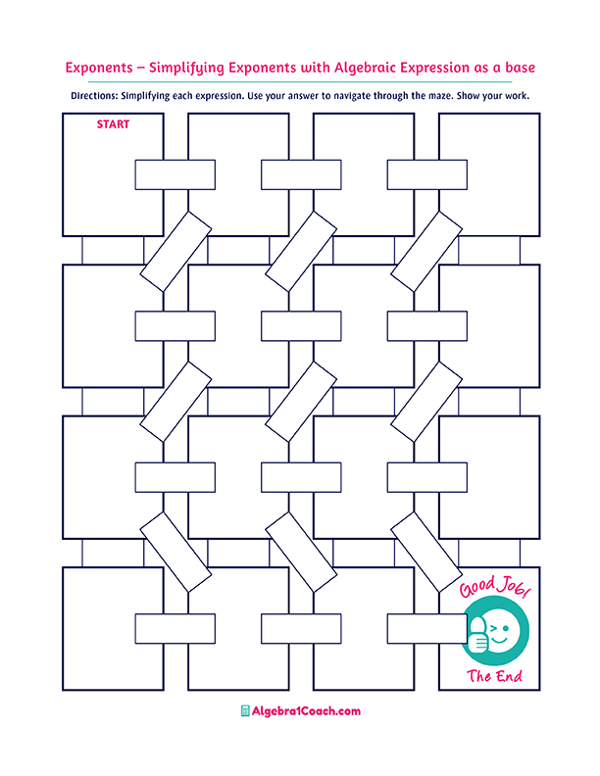

**What percent of 20 is 15?**

**5% of what number is 4?**

**115% of what number is 120?**

$$12\% of 350$$

**60% of what number is 75?**

$$1.55\%$$

$$116$$

$$75\%$$

**What percent**

**of 45 is 7?**

$$40\% of 400$$

$$2.2\%$$

$$0.022\%$$

**What percent**

**of 500 is 11?**

**What percent**

**of 600 is 65?**

$$6\% of 150$$

$$15\%$$

$$0.2\% of 200$$

$$1.6$$

$$40$$

$$16\% of 10$$

$$80$$

$$125$$

$$24$$

$$6$$

$$9$$

$$20\%$$

$$42$$

$$10.83\%$$

**What percent**

**of 120 is 24?**

$$10\%$$

$$12\% of 180$$

$$15.55\%$$

**What percent**

**of 1,250 is 125?**

$$160$$

$$0.1555\%$$

$$100$$

$$155.5\%$$

$$0.4$$

$$65\%$$

$$8$$

$$18$$

$$104.35$$

$$0.22\%$$

$$10\%$$

$$80$$

$$21.6$$

$$55\%$$

$$22\%$$