Percentages
Directions: Solve each problem. Use your answer to navigate through the maze. Show your work.
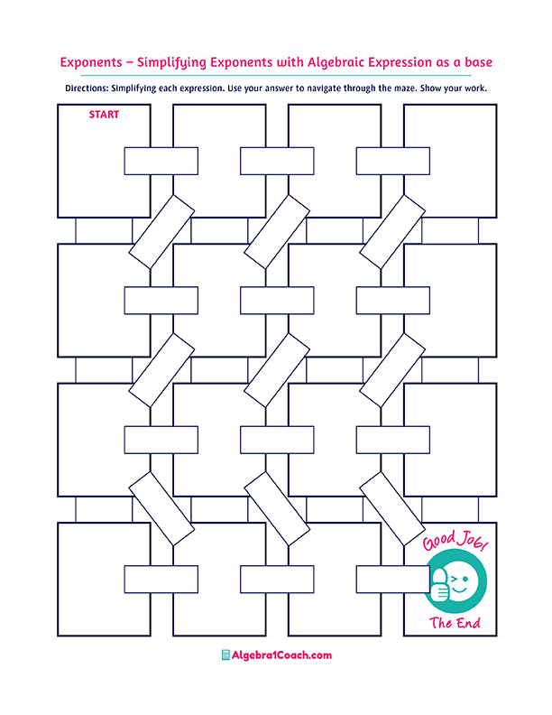
115% of what number is 120?
$$12\% of 350$$
5% of what number is 4?
60% of what number is 75?
$$1.55\%$$
$$116$$

$$75\%$$
What percent
of 45 is 7?

$$40\% of 400$$

$$2.2\%$$

$$0.022\%$$

What percent
of 500 is 11?

What percent
of 600 is 65?

What percent of 20 is 15?
$$6\% of 150$$

$$15\%$$
$$0.2\% of 200$$

$$1.6$$

$$40$$

$$16\% of 10$$

$$80$$

$$125$$
$$24$$
$$6$$

$$9$$

$$20\%$$

$$42$$

$$10.83\%$$

What percent
of 120 is 24?

$$10\%$$
$$12\% of 180$$

$$15.55\%$$

What percent
of 1,250 is 125?

$$160$$
$$0.1555\%$$
$$100$$
$$155.5\%$$

$$0.4$$

$$65\%$$

$$8$$
$$18$$

$$104.35$$
$$0.22\%$$
$$10\%$$
$$80$$
$$21.6$$
$$55\%$$

$$22\%$$

