- Place each number in the most SPECIFIC categories of real numbers they belong.

$$-14$$ |  | $$-6$$ | $$-\frac{2}{5}$$ | $$30$$ |  | $$\frac{3}{2}$$ | $$-\frac{4}{9}$$ | $$0.66$$ | $$0$$ | $$8.52$$ | $$-69.99$$
 | Real Numbers :
 | Irrational Numbers :
 | Rational Numbers :
 | Non-integers :
 | Integers :
 | Negative Numbers :
 | Whole Numbers :
 | Zero :
 | Natural Numbers :

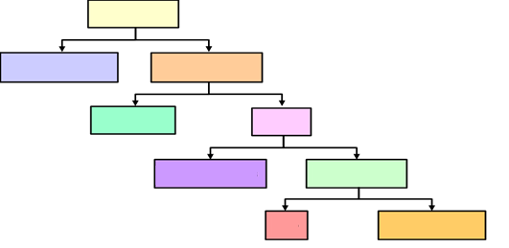
- Complete the diagram with the family of real numbers.

3. Represent the following with integers.
a. | An increase of $10 weekly allowance
b. | Raising the flag 3 feet higher
c. | Diving 150 meters below sea level
d. | Going down the stairs 15 steps
e. | Walking 10 blocks south
f. | Weight increase of 1.5 kilograms
g. | A bank deposit of $1000
h. | $100 Tom owes from a friend

- Arrange the following real numbers as instructed.

- Descending

$$9, -1, 10, 0, 2, 1, -8, -7$$

- Ascending

$$\frac{1}{3}, -\frac{1}{2}, -5, -\frac{2}{3}, 2, -3$$

- Name the coordinates of the points graphed on each number line.

2
3
4
5
6
1
0
-1
-2

$$-\frac{2}{3}$$
$$-\frac{1}{3}$$
0
$$\frac{1}{3}$$
$$\frac{2}{3}$$
-1
$$-\frac{4}{3}$$
$$-\frac{5}{3}$$
-2

- Graph each set of numbers.

$$\left\{-1, 0,\frac{1}{2},\frac{3}{4},\frac{3}{2}\right\}$$

$$\left\{-1.5,-\frac{1}{4}, 2, 3\frac{1}{2}, -4.5\right\}$$

- Find each absolute value.
 | $$\left|-14\right|$$ |  | $$\left|18\right|$$ |  | $$\left|2.6\right|$$ |  | $$\left|-\frac{1}{15}\right|$$
 | $$\left|-80\right|$$ |  | $$\left|11\right|$$ |  | $$\left|72\right|$$ |  | $$\left|-4\right|$$

