Answers:
- Is $-\frac{1}{2}$ an integer? Justify your answer.

Answer: $-\frac{1}{2}$ is not an integer because an integer must be a whole number or zero. $-\frac{1}{2}$ is not a whole number.

- Name the points graphed on each number line.

a) | 0  1  2  3  4  -1  -2  -3  -4  -3  -2  -1  1  3
b) | -4  -3  -2  -1  0  -5  -6  -7  -8  -8  -7  --5  -3  -4  -1

- Graph each set of numbers.

a) | $$\left\{-3, -2,\frac{1}{3},-1,-\frac{1}{3}, \frac{2}{3}, 0\right\}$$  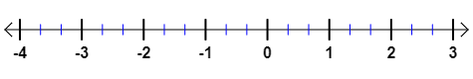  -3  -2  -1  $$\frac{2}{3}$$  $$0$$  $$-\frac{1}{3}$$  $$\frac{1}{3}$$
b) | $$\left\{-6.3, -7.4, -6, -4.5, -2.2\right\}$$  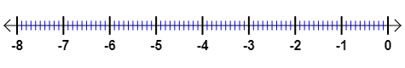  6  -4.5  -2.2  -7.4  -6.3
- Arrange the real numbers below in ascending order: $-2.5, -1, 0, -1\frac{1}{2}, -\frac{1}{2}, 0.5, 1\frac{1}{4}$

Answer: $-2.5, -1\frac{1}{2}, -1, -\frac{1}{2}, 0, 0.5, 1\frac{1}{4}$

- Represent the situation below with integers:

Tom’s score in his Math quiz decreased by 3 points.

Answer: -3

- Find each absolute value.
a) | $$\left|4.1\right|$$  Answer: 4.1 | b) | $$\left|-6.2\right|$$  Answer: 6.2 |  | $$\left|-\frac{11}{45}\right|$$  Answer: $\frac{11}{45}$ |  | $$\left|22.60\right|$$  Answer: 22.60

