

**Algebra 1**

UNIT 1 – Interactive Notebook

**1-1 The Real Number System**

|  |  |  |  |
| --- | --- | --- | --- |
| **Name:** |  | **Date:** |  |

|  |  |
| --- | --- |
| **Common Core Standards** | [CCSS.MATH.CONTENT.8.NS.A.1](http://www.corestandards.org/Math/Content/8/NS/A/1/) Know that numbers that are not rational are called irrational. Understand informally that every number has a decimal expansion; for rational numbers show that the decimal expansion repeats eventually, and convert a decimal expansion which repeats eventually into a rational number. |

**THE SET OF REAL NUMBERS**

The diagram below shows how real numbers are classified.



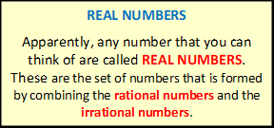

**REAL NUMBERS can be IRRATIONAL or RATIONAL.**

**IRRATIONAL NUMBERS**

**Irrational** means “**not rational**”. These are the set of all numbers whose decimal representation are neither terminating nor repeating. It cannot be expressed as a quotient of integers. These numbers cannot be expressed as a ratio of two numbers

**Examples:**

$$π, e, \frac{22}{7}, \sqrt{2}, \sqrt{3}, \sqrt{7 }$$

**RATIONAL NUMBERS**

These are the set of all numbers which can be expressed in the form: $\frac{a}{b}$, where $a$ and $b$ are integers and $b$ is not equal to $0$, written as $b≠0$. It can be expressed as **terminating** or **repeating** decimals.

**Examples:**

$$\frac{3}{4}, \frac{27}{11}, -2, -1, 0, 100, -25, 3.75$$

**RATIONAL NUMBERS can be NON-INTEGERS or INTEGERS.**

**RATIONAL NUMBERS can be NON-INTEGERS or INTEGERS.**

**NON-INTEGERS**

These are the set of all numbers that is neither a positive whole number, nor a negative whole number, nor zero. These include **decimals**, **fractions**, and **imaginary numbers**.

**Examples:**

$$\frac{3}{4},\frac{27}{11}, 9i, -\frac{1}{2}, -0.25, 1.75, \frac{5}{7}, 3\frac{2}{3}$$

**INTEGERS**

These are the set of numbers formed by **positive whole numbers**, **negative whole numbers**, and **zero**.

**Examples:**

$$…,-3,-2, -1, 0, 1, 2, 3,…$$

**INTEGERS can be NEGATIVE or WHOLE NUMBERS.**

**NEGATIVE INTEGERS**

These are whole numbers **less than zero** and usually mean a value that is a deficit or shortage.

**Examples:**

$$…, -5, -4, -3,-2, -1$$

**WHOLE NUMBERS**

These are the set of numbers formed by adding **0** to the set of **natural numbers** (also called as counting numbers).

**Examples:**

$$0, 1, 2, 3, 4, 5, 6,7, 8,9, 10, 11,…$$

**WHOLE NUMBERS include ZERO and POSITIVE INTEGERS.**

**ZERO**

**Zero** denotes the absence of all magnitude or quantity.

$$0$$

**POSITIVE INTEGERS**

These are the set of numbers that include all **natural numbers** (also known as **counting numbers**)

**Examples:**

$$1, 2, 3, 4, 5, 6, 7, 8,…$$

**Make it REAL!**

Complete the diagram by making your own real number given its classification.

**REAL NUMBERS ON THE NUMBER LINE**

A **NUMBER LINE** is a straight line with numbers written in equal intervals. It can be used to show the sets of **real numbers** composed of **rational** and **irrational numbers**. On a **REAL NUMBER LINE**:

* There is a point that corresponds for every real number.
* There is a real number for each point.

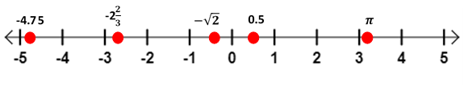

**OPPOSITES**

In Mathematics, on the other hand, OPPPOSITES are denoted by the following signs:

$$+$$

**Positive Sign**

This symbol is written before a number that is positive.

**Example: $+7$** is read as “**positive 7**”

If there no sign before a number, then that number is considered positive.

**Example:** **7** is understood to be “**positive 7**”

$$-$$

**Negative Sign**

This symbol is written before a number that is negative.

**Example: $-7$** is read as “**negative 7**”

It is very important to write that symbol before a negative number to indicate that it is negative.

**Example:** **-10** is read as “**negative 10**”

**Also, ZERO IS NEITHER POSITIVE NOR NEGATIVE.**

**OPPOSITES ATTRACT!**

Represent the following statements with integers.

|  |  |
| --- | --- |
| **STATEMNENTS** | **INTEGER** |
| A withdrawal of $1,000,000 |  |
| An increase of 5 degrees in temperature |  |
| Oil leakage of 25 liters |  |
| 2 points increase in exam scores |  |

State the opposite of the of the given statements above and represent with an integer.

|  |  |
| --- | --- |
| **STATEMNENTS** | **INTEGER** |
|  |  |
|  |  |
|  |  |
|  |  |

**Task Cards**

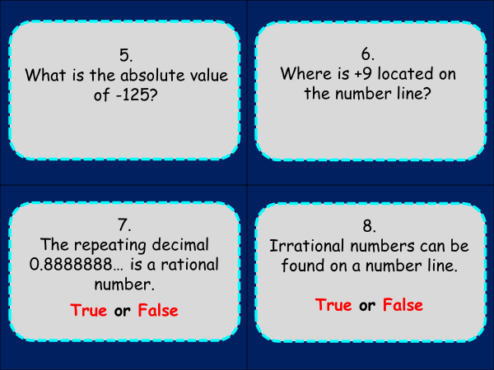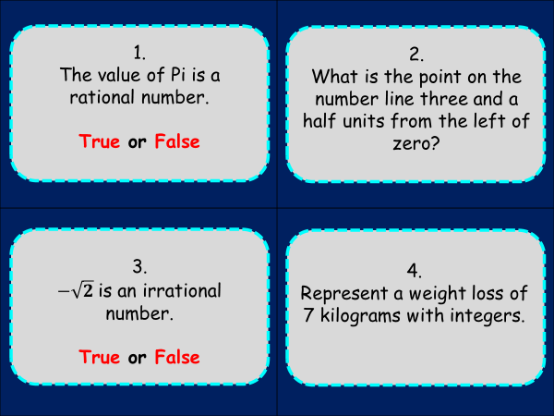

Answers:

**Make It Real!**

Students answers may vary.

**Opposites Attract!**

|  |  |
| --- | --- |
| **STATEMNENTS** | **INTEGER** |
| A withdrawal of $1,000,000 | -1,000,000 |
| An increase of 5 degrees in temperature | +5 |
| Oil leakage of 25 liters | -25 |
| 2 points increase in exam scores | +2 |

|  |  |
| --- | --- |
| **STATEMNENTS** | **INTEGER** |
| A deposit of $1,000,000 | +1,000,000 |
| A decrease of 5 degrees in temperature | -5 |
| Oil refill of 25 liters | +25 |
| 2 points decrease in exam scores | -2 |

**Task Cards**

1. **FALSE**
$-3\frac{1}{2}$

2. **TRUE**
3. **-7**
4. **125**
5. **9 units to the right of zero.**
6. **TRUE**
7. **TRUE**